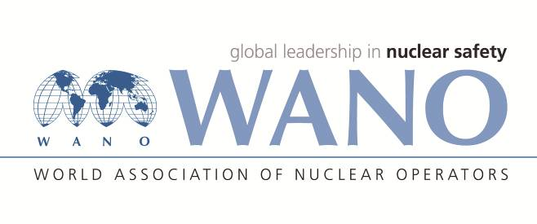 | World Association of Nuclear Operators  Moscow Centre  WANO – MC  25 Ferganskaya, Moscow, 109507, Russia  Phone. +7 495 376 15 87  Fax: +7 495 376 08 97  info@wanomc.ru

REQUEST
to provide technical and organisational information via WANO

- NPP/Organisation: SS Rivne NPP/SE NNEGC “Energoatom”

- Topic of information request:
SPV (Single Point Vulnerability) plant programme
- Goal of information request:
Study the experience of NPPs with VVER-440/1000 reactor types for its further implementation
- Problem description:
Single failure-related events, including reactor scrams, occur at the NPP periodically. An event cause analysis, including the industry – level analysis, proves that events have a single failure nature. Therefore, the plant is interested in taking additional actions (approaches) to determine (identify) equipment vulnerable to single failures.
- Specific questions:
- Is the SPV programme implemented at your NPP? Is there a document that describes approaches to managing SPV components?
- A list of SPV equipment (its operating name, description, system)
- Have the SPV programme performance indicators been developed? Is the programme effectiveness self-assessment performed and with what frequency?
- Roles of a department that supports the SPV programme, the number and qualification of its staff.
- Proposed organizations to send the request to:
All NPPs, members of WANO-MC, with VVER--440/1000 reactor types.
- Department – request initiator:
Equipment Reliability and Lifetime Extension department
- Contact details of the requester:
Treushchenko A. V., head of the reliability and operation experience unit of the equipment reliability and lifetime extension department
+380363664908 treav@rnpp.atom.gov.ua
- Date of request:
02/12/2021

