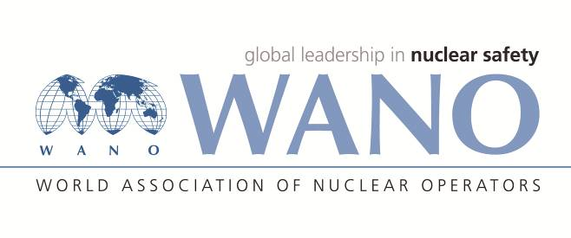 | Moscow Centre  WANO-MC  25 Ferganskaya, Moscow, 109507, Russia  Phone: +7 495 376 15 87  Fax: +7 495 376 08 97  info@wanomc.ru

Benchmarking expert personal form

General information

BM place: Slovenske Elektrarne company (Slovakia)
BM topic: Corporate PI System Experience
BM date: November 11-17 or 18-24, 2019
BM working language: English (with interpreter)
BM coordinator from WANO-MC: Ivan Goncharov
Phone number: +7495221 02 73
e-mail: goncharov@wanomc.ru

Expert data

Name
Surname
Date of birth
Place of birth
Citizenship
Passport number
(please send the scan copy)
Passport issue date
Passport expire date
Job Title
Station
Company / Organization
Work Address
Telephone
Home address
Fax
E-mail
Mobile phone
Size of clothing
Shoes
Height

