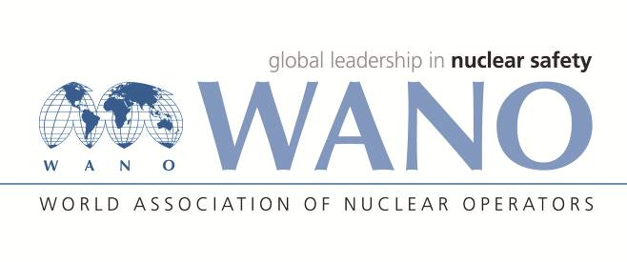 | World Association of Nuclear Operators  Moscow Centre  WANO – MC  25 Ferganskaya, Moscow, 109507, Russia  Phone. +7 495 376 15 87  Fax: +7 495 376 08 97  info@wanomc.ru
REQUEST
to provide technical and organizational information via WANO.
- NPP/Organization: Kozloduy NPP
- The topic of information request:
Equipment qualification for severe accidents
- The goal of information request:
To obtain information from other power plants on equipment qualification for severe accidents
- The describing of problem: Expansion of the Equipment Qualification System for Severe Accidents
- Questions:
1. Regarding the environmental profiles, did you perform (considering to perform) some analysis/simulations of severe accidents or from data obtained from actual severe accidents that have occurred.
2. How did you estimate (considering to estimate) the mission times for which the reliable performance is to be assessed
3. Regarding monitoring of fission product barrier integrity, which plant instrumentation dedicated for monitoring fission product barrier integrity is used (considering using).
4. Which equipment qualification standards and regulations did you use (considering to use) for demonstration of the suitability of equipment for severe accidents
5. Please explain qualification methods for qualifying electrical and I&C equipment important to safety for severe accidents which is used in your qualification program
- Proposed organizations for sending this request:
All WANO members
- Department – request initiator: Kozloduy NPP
- Contact details of the requester:
Name, Surname: Biser Radoslavov
Position: Equipment Qualification Group Leader, Kozloduy NPP Plc.
Phone: +359 973 7 61 47
Mobile: +359 877 404 234
e-mail: BERadoslavov@npp.bg
- Date of request: November 15, 2021
Responsible person: Veselin Nikolov, WANO contact person Name, surname.
Executor
Name, surname.
Phone

