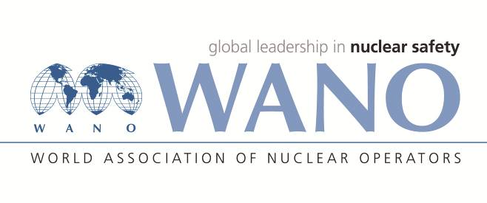 | Московский центр  Всемирная Ассоциация Организаций, эксплуатирующих Атомные Электростанции  ВАО АЭС – МЦ  Россия, 109507, Москва, Ферганская ул., 25  Тел. +7 495 376 15 87  Факс: +7 495 376 08 97  info@wanomc.ru

REQUEST
to provide technical and organizational information via WANO
- NPP/Organization:
Rivne NPP / SE NNEGC "Energoatom"
- The topic of information request:
Changing the interval between designed functional tests of safety related equipment
- The goal of information request:
Obtain information regarding experience of changing the interval between designed functional tests of safety related equipment. Methodology to analyze the impact of that change on overall nuclear safety.
- Description of the problem:
Ukrainian Nuclear industry does not possess neither experience nor regulatory base and approval for conducting the design change process to modify the interval between designed functional tests of safety related equipment.
- Questions:
1. Has your NPP ever performed a design change process to modify the interval between designed functional tests of safety related equipment?
2. What systems and equipment have been subject of the design change named above?
3. Can you please describe in detail the methodology which was used to analyze and validate such change?
4. Describe the methods used to estimate the impact of this design change on overall nuclear safety
5. What parameters were analyzed? (e.g. equipment unavailability times, equipment actuation cycles and others)
6. What lasting practical benefits did you gain following such change?
- Proposed organizations:
NPPs, utilities
- Department – request initiator:
Rivne NPP, Safety analysis department
- Contact details of the requester:
Nikolai Divisenko, Head of safety analysis department. dina@rnpp.atom.gov.ua
- Date of request:
14.09.2021.

