GENERAL DISTRIBUTION



WANO

Moscow Centre

Peer Review Group

**Safety Culture Review Guide**

General Distribution: Copyright © 2022 by the World Association of Nuclear Operators. Not for sale or for commercial use. Translations are permitted. Reproduction of this document by Members for internal use or use by its contractors for the limited and exclusive purpose of Member business is permitted. Not for public distribution, delivery to, or reproduction by any third party without the prior agreement of WANO. All other rights reserved.

**CONTENT**

Introduction 3

Definition of nuclear safety culture 3

Review Guide on Nuclear Safety Culture Traits 4

Nuclear Safety Culture Traits and Attributes 6

Appendix A Example how to fill out the file 11

Appendix B Indications of Degraded Safety Culture 13

Appendix C Sample List of Safety Culture Behaviors 17

Appendix D Data Collection Algorithm for NSC Assessment 19

# Introduction

This manual contains the formulation of features and criteria for a healthy safety culture in accordance with WANO GL 2013-1 and is intended for assessing the state of safety culture at the NPP being reviewed.

This guide is issued to peer reviewers during team training. Each reviewer is invited to familiarize with the content of the manual and use it when assessing the state of safety culture at the NPP being reviewed.

At the end of the peer review, all experts submit the completed files to the responsible safety culture experts for further analysis and generalization of the survey results.

Dedicated team members prepare a part of the final peer review report describing the state of safety culture at the NPP being reviewed, based on feedback from each reviewer and on an analysis of the facts included in the forms, both negative and positive.

# Definition of nuclear safety culture

Nuclear safety culture is defined as the core values and behaviors resulting from a collective commitment by leaders and individuals to emphasize safety over competing goals, to ensure protection of people and the environment.

For the commercial nuclear power industry, nuclear safety remains the overriding priority. Although the same traits apply to radiological safety, industrial safety, security and environmental safety; nuclear safety is the first value adopted at a nuclear station and is never abandoned.

In addition to a healthy organizational culture, the special characteristics and unique hazards associated with nuclear technology – radioactive by-products, concentration of energy in the reactor core and decay heat – mean each station needs a healthy safety culture.

# Review Guide on Nuclear Safety Culture Traits

This review guide on “Nuclear Safety Culture Traits” covers three (3) sections:

* 1. A systematic way to help review safety culture behaviors, attitude, and environment in the station.
  2. Possible indications of plant safety culture behaviors and environment are degrading. The indications in each review area will help team evaluate plant safety culture and identify gaps that need to be minimized. (Reference material). Appendix B.
  3. A sample list of safety culture behaviors which could be referenced to help review activities. Also, it could help reviewers strengthen behaviors at their organizations. (Reference material). Appendix C.

This guide is distributed to each reviewer 1-2 months before a PR as part of the documents and reference materials sent by the PP coordinator.

At the end of the first week of observation at the plant, each reviewer must consider all ten of nuclear safety culture features (see pages 5-10) and submit the results of the observations to the Organizational Effectiveness (OA) group in order to form a team-wide NSC assessment result.

The survey results must be entered into the file «NSC Survey_Template.xlsx» and save the file by changing its name in terms of replacing the word "Template" with the review area, for example, "OP1". The number at the end specifies the expert, i.e. the area lead in the "Operations" will designate the file "OP1", and the second or third reviewer will designate the file "OP2" or "OP3" respectively.

The template file "NSC Survey_Template.xlsx" is used only for technical records of a reviewer.

Typically, each reviewer make notes about Nuclear Safety Culture facts (if any) in the file described above during the review period and submits the completed review results (in electronic version) to the Organizational Effectiveness (OA) area reviewer, up to 10:00 of the second Saturday of the PR for further safety culture analysis.

The assessment by each reviewer is highly individual and it depends on personal experience and opinion of the reviewer. Each reviewer assesses every trait from all ten Safety Culture Traits on pages 5-10, and writes facts/examples/reasons that support his/her opinion. He/She summarises his/her results into the file «NSC Survey _NNX.xlsx», where he/she marks each trait in the selected color with the number "1". The color determines the grade.

We use a Color Coding as follows:

|  |  |  |
| --- | --- | --- |
| **G** | **Green** | **This is an area of excellent performance, i.e. a model for other stations (write examples)** |
| **W** | **White** | **This is an area of acceptable performance, i.e. meets min. standards. (no examples needed)** |
| **Y** | **Yellow** | **This is an area of low performance, i.e. below industry excellence. (write facts or impressions)** |
| **R** | **Red** | **This is a problem area for the station. (write facts)** |
| **B** | **Blue** | **No data or observations for drawing a conclusion. (no examples)** |

Examples how to fill out the form are given in the Appendix A.

The dedicated team member will develop an observation report based on feedback from each team member and analyze the relevant "Facts/Examples/Causes" listed in the forms, the results will be discussed with all PR team members at a meeting where a decision was made to form or not to form the Area for improvement in safety culture. In addition, the OA team will prepare final results in the area of safety culture and these will be included in the dedicated section of the Peer Review Report.

# Nuclear Safety Culture Traits and Attributes

1. **Personal Accountability (РА)**

**All individuals take personal responsibility for safety. Responsibility and authority for nuclear safety are well defined and clearly understood. Reporting relationships, positional authority, and team responsibilities emphasize the overriding importance of nuclear safety.**

Attributes:

PA.1 Standards: Individuals understand the importance of adherence to nuclear standards. All levels of the organization exercise accountability for shortfalls in meeting standards.

PA.2 Job Ownership: Individuals understand and demonstrate personal responsibility for the behaviors and work practices that support nuclear safety.

PA.3 Teamwork: Individuals and work groups communicate and coordinate their activities within and across organizational boundaries to ensure nuclear safety is maintained..

1. **Questioning Attitude (QA)**

**Individuals avoid complacency and continuously challenge existing conditions, assumptions, anomalies, and activities in order to identify discrepancies that might result in error or inappropriate action. All employees are watchful for assumptions, values, conditions, or activities that can have an undesirable effect on plant safety.**

Attributes:

QA.1 Nuclear is recognized as Special and Unique: Individuals understand that complex technologies can fail in unpredictable ways.

QA.2 Challenge the Unknown: Individuals stop when faced with uncertain conditions. Risks are evaluated and managed before work proceeds.

QA.3 Challenge Assumptions: Individuals challenge assumptions and offer opposing views when they believe something is not correct.

QA.4 Avoid Complacency: Individuals recognize and plan for the possibility of mistakes, latent issues, and inherent risk, even while expecting successful outcomes.

1. **Safety Communication (СО)**

**Communications maintain a focus on safety. Safety communication is broad and includes plant-level communication, job-related communication, worker-level communication, equipment labeling, operating experience, and documentation. Leaders use formal and informal communication to convey the importance of safety. The flow of information up the organization is seen as important as the flow of information down the organization.**

Attributes:

CO.1 Work Process Communications: Individuals incorporate safety communications in work activities.

CO.2 Bases for Decisions: Leaders ensure that the bases for operational and organizational decisions are communicated in a timely manner.

CO.3 Free Flow of Information: Individuals communicate openly and candidly, both up, down, and across the organization and with oversight, audit, and regulatory organizations.

CO.4 Expectations: Leaders frequently communicate and reinforce the expectation that nuclear safety is the organization’s overriding priority.

1. **Leadership Accountability (LA)**

**Leaders demonstrate a commitment to safety in their decisions and behaviors. Executive and senior managers are the leading advocates of nuclear safety and demonstrate their commitment both in word and action. The nuclear safety message is communicated frequently and consistently, occasionally as a stand-alone theme. Leaders throughout the nuclear organization set an example for safety. Corporate policies emphasize the overriding importance of nuclear safety.**

Attributes:

LA.1 Resources: Leaders ensure that personnel, equipment, procedures, and other resources are available and adequate to support nuclear safety.

LA.2 Field Presence: Leaders are commonly seen in working areas of the plant observing, coaching, and reinforcing standards and expectations. Deviations from standards and expectations are corrected promptly.

LA.3 Incentives, Sanctions, and Rewards: Leaders ensure incentives, sanctions, and rewards are aligned with nuclear safety policies and reinforce behaviors and outcomes that reflect safety as the overriding priority.

LA.4 Strategic Commitment to Safety: Leaders ensure plant priorities are aligned to reflect nuclear safety as the overriding priority.

LA.5 Change Management: Leaders use a systematic process for evaluating and implementing change so that nuclear safety remains the overriding priority.

LA.6 Roles, Responsibilities, and Authorities: Leaders clearly define roles, responsibilities, and authorities to ensure nuclear safety.

LA.7 Constant Examination: Leaders ensure that nuclear safety is constantly scrutinized through a variety of monitoring techniques, including assessments of nuclear safety culture.

LA.8 Leader Behaviors: Leaders exhibit behaviors that set the standard for safety.

1. **Decision-Making (DM)**

**Decisions that support or affect nuclear safety are systematic, rigorous, and thorough. Operators are vested with the authority and understand the expectation, when faced with unexpected or uncertain conditions, to place the plant in a safe condition. Senior leaders support and reinforce conservative decisions.**

Attributes:

DM.1 Consistent Process: Individuals use a consistent, systematic approach to make decisions. Risk insights are incorporated as appropriate.

DM.2 Conservative Bias: Individuals use decision-making practices that emphasize prudent choices over those that are simply allowable. A proposed action is determined to be safe in order to proceed, rather than unsafe in order to stop.

DM.3 Accountability for Decisions: Single-point accountability is maintained for nuclear safety decisions.

1. **Respectful Work Environment (WE)**

**Trust and respect permeate the organization, creating a respectful work environment. A high level of trust is established in the organization, fostered, in part, through timely and accurate communication. Differing professional opinions are encouraged, discussed, and resolved in a timely manner. Employees are informed of steps taken in response to their concerns.**

Attributes:

WE.1 Respect is Evident: Everyone is treated with dignity and respect.

WE.2 Opinions are Valued: Individuals are encouraged to voice concerns, provide suggestions, and raise questions. Differing opinions are respected.

WE.3 High Level of Trust: Trust is fostered among individuals and work groups throughout the organization.

WE.4 Conflict Resolution: Fair and objective methods are used to resolve conflicts.

1. **Continuous Learning (CL)**

**Opportunities to continuously learn are valued, sought out, and implemented. Operating experience is highly valued, and the capacity to learn from experience is well developed. Training, self-assessments, and benchmarking are used to stimulate learning and improve performance. Nuclear safety is kept under constant scrutiny through a variety of monitoring techniques, some of which provide an independent “fresh look.”**

Attributes:

CL.1 Operating Experience: The organization systematically and effectively collects, evaluates, and implements lessons from relevant internal and external operating experience information in a timely manner.

CL.2 Self-Assessment: The organization routinely conducts self-critical and objective assessments of its programs, practices, and performance.

CL.3 Benchmarking: The organization learns from other organizations to continuously improve knowledge, skills, and safety performance.

CL.4 Training: High-quality training maintains a knowledgeable workforce and reinforces high standards for maintaining nuclear safety.

1. **Problem Identification and Resolution (PI)**

**Issues potentially impacting safety are promptly identified, fully evaluated, and promptly addressed and corrected commensurate with their significance. Identification and resolution of a broad spectrum of problems, including organizational issues, are used to strengthen safety and improve performance.**

Attributes:

PI.1 Identification: The organization implements a corrective action program with a low threshold for identifying issues. Individuals identify issues completely, accurately, and in a timely manner in accordance with the program.

PI.2 Evaluation: The organization thoroughly evaluates issues to ensure that problem resolutions and solutions address causes and extents of conditions commensurate with their safety significance.

PI.3 Resolution: The organization takes effective corrective actions to address issues in a timely manner commensurate with their safety significance.

PI.4 Trending: The organization periodically analyzes information from the corrective action program and other assessments in the aggregate to identify adverse trends or conditions.

1. **Environment for Raising Concerns (RC)**

**A safety-conscious work environment (SCWE) is maintained where personnel feel free to raise safety concerns without fear of retaliation, intimidation, harassment, or discrimination. The station creates, maintains, and evaluates policies and processes that allow personnel to freely raise concerns.**

Критерии:

RC.1 SCWE Policy: The organization implements a policy that supports individual rights and responsibilities to raise safety concerns and does not tolerate harassment, intimidation, retaliation, or discrimination for doing so.

RC.2 Alternate Process for Raising Concerns: The organization implements a process for raising and resolving concerns that is independent of line management influence. Safety issues may be raised in confidence and are resolved in a timely and effective manner.

1. **Work Processes (WP)**

**The process of planning and controlling work activities is implemented so that safety is maintained. Work management is a deliberate process in which work is identified, selected, planned, scheduled, executed, closed, and critiqued. The entire organization is involved in and fully supports the process.**

Attributes:

WP.1 Work Management: The organization implements a process of planning, controlling, and executing work activities such that nuclear safety is the overriding priority. The work process includes the identification and management of risk commensurate to the work.

WP.2 Design Margins: The organization operates and maintains equipment within design margins. Margins are carefully guarded and changed only through a systematic and rigorous process. Special attention is placed on maintaining fission product barriers, defense-in-depth, and safety-related equipment.

WP.3 Documentation: The organization creates and maintains complete, accurate, and up-to-date documentation.

WP.4 Procedure Adherence: Individuals follow processes, procedures, and work instructions.

# Appendix A Example how to fill out the file

**«NSC Survey _Template.xlsx» File format**

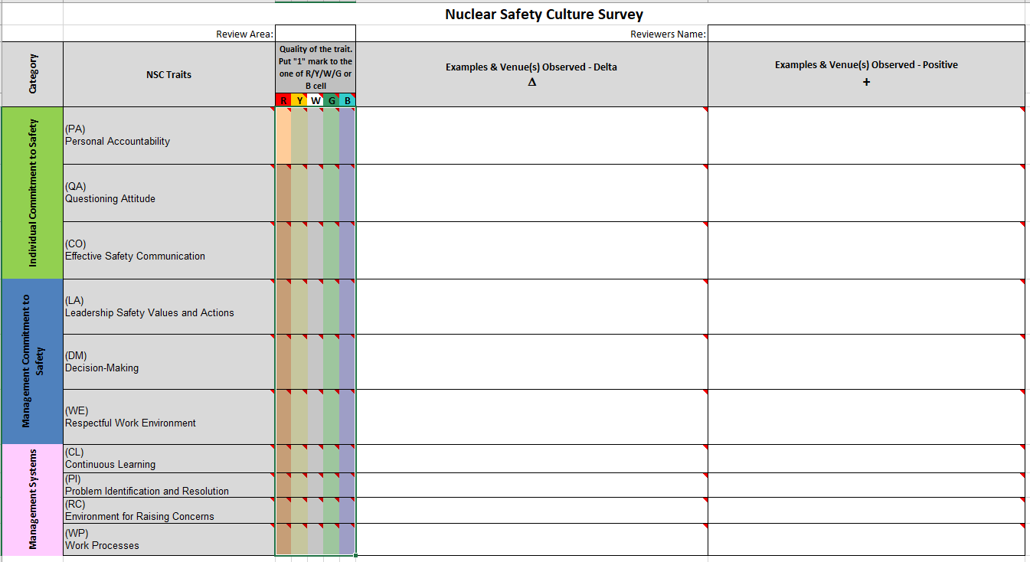

**Appendix A (extension)**

**An example of filling out the file "NSC Survey _Template.xlsx"**

**on 10 features of nuclear safety culture**

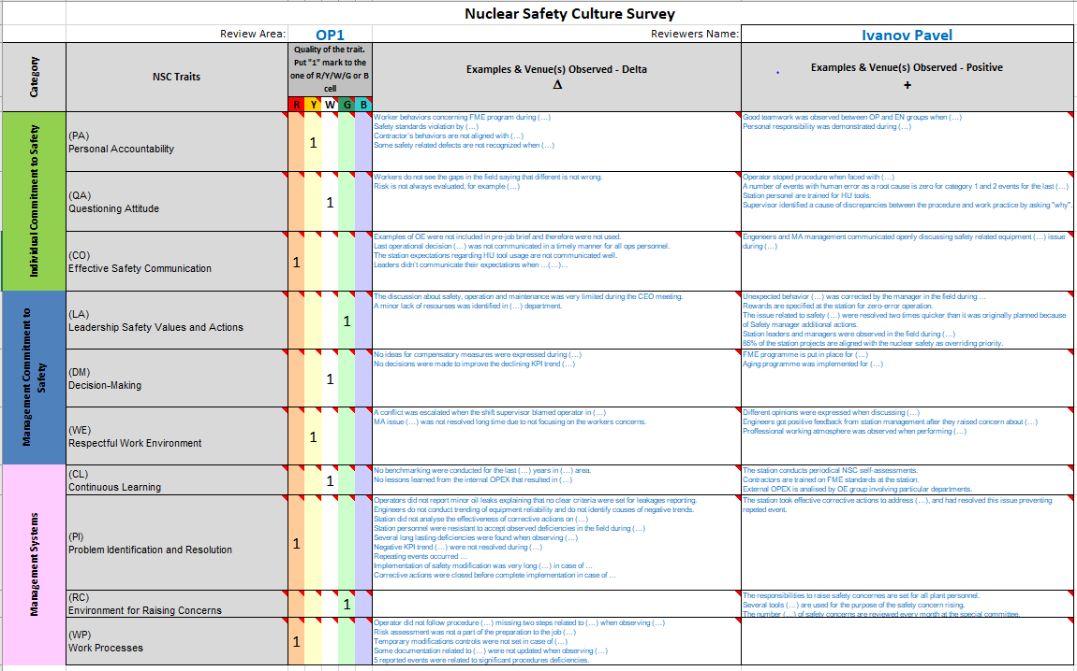

# Appendix B Indications of Degraded Safety Culture

The following paragraphs provide some indications of weaknesses in safety culture in different review areas. Each paragraph contains a list of indications of weakness, to assist reviews in identifying worker behaviors and performance that may be precursors to a decline in nuclear safety culture. The list is not all inclusive and is intended as stimulation for discussion regarding safety culture from respective area perspective, and should not be used as a check-list. Should a reviewer identify that several of these or similar issues exist at a site, it is an indication that discussions regarding a weakened safety culture should be explored with the OR reviewers and other leads. Consideration should be given to including these examples in the safety culture observation written by the OR team.

**Possible Indications of Degraded Safety Culture in Operations Area.**

* Weaknesses exist in the management of operational risk. Example include a plant’s inability to manage the aggregate impact of degraded equipment, especially operator workarounds and control room deficiencies, organizational weaknesses in the management of reactivity, and inadequate reviews of activities that could affect nuclear safety during refueling outages.
* Weaknesses in operational-decision making have close ties to safety culture, especially in the areas of identifying low-level issues that could impact nuclear safety, questioning attitude, and contingency planning.
* Plants that have had precipitous declines in performance have had large operational focus issues. These weaknesses are most often manifested in the plants ability to work together to address equipment issues and operations inability or unwillingness to lead the plant efforts in this area.
* Weakness in operator fundamentals, especially monitoring and controlling plant evolutions can be indicative of safety culture weaknesses. The closer to the core these issues touch, the closer the tie can be. For example, weaknesses in operator human performance that result in reactivity management consequences or safety system unavailability are prime areas for exploration. Management identification and resolution of these issues can also provide insight into the site’s safety culture.
* Conservative decision-making, especially as it relates to Davis Besse event has close ties to nuclear safety culture.
* Management’s ability and willingness to keep a strong operations pipeline can have long-term effects on a plant’s safety culture.

**Possible Indications of Degraded Safety Culture in Maintenance Area.**

* The causes of maintenance induced plant transients and shutdowns are not fully explored.
* Corrective and elective maintenance backlog is above warning flag values of 50 and 500 per unit respectively. A strategy is not in place to systematically reduce backlogs.
* Outage scope deletions of safety related work occur routinely at the end of an outage as overruns of budget and duration occur.
* Any loss of key safety function, such as shutdown cooling occurs during an outage.
* Defense-in-depth is not in well maintained in accordance with industry guidance.
* Preventative maintenance tasks are routinely delinquent or worked deep in grace.
* Outage milestones are routinely missed.
* The plant does not demonstrate the appropriate level of accountability for regular and supplemental worker performance.
* A culture of tolerance for working around degraded work instructions or procedures is evident.

**Possible Indications of Degraded Safety Culture in Chemistry Area.**

* Technicians do not write condition reports and do not bring up issues to supervision and plant CAP system.
* Technicians do not maintain awareness of protective trains required by work maintenance.
* Technicians do not recognize and understand plant chemistry safety implications.
* Supervisors do not coach in the field and chemistry deviations are not promptly communicated to operations personnel.
* Chemistry technicians hesitate to challenge decisions.
* Chemistry technicians do not recognize parameters important to nuclear safety e.g. eff. gas sample, boron analysis (PWR), and related Tech. Specs.
* The decision making by the Chemistry managers do not reflect maintaining proper chemistry and managers do not advocate conservative/operational decision-making when chemistry parameters exceed required limits.
* Out of spec. chemistry conditions are not communicated to supervision.
* Out of spec. chemistry conditions are not captured in the CAP process.
* Accurate results for boron and failed fuel analysis are not reported in a timely manner to management. (PWR)

**Possible Indications of Degraded Safety Culture in Equipment Reliability and Engineering.**

* The number of longstanding or repetitive degraded conditions is high on safety significant equipment and aggressive action is not taken to correct.
* On-line and outage scope decisions do not adequately consider the risk and safety impact of important equipment reliability concerns and engineers are not involved in outage scope decisions.
* A degraded equipment condition has not been recognized or is not questioned by the organization commensurate with its safety significance.
* Operability determinations or ODMI’s written for degraded equipment conditions lack scope or sufficient detail, but have been accepted by the organization.
* System, component, & program health reports do not accurately capture worsening trends of degraded conditions, aging, or obsolescence of safety-significant equipment.
* Plant health committee and plant management do not rigorously challenge assumptions or question system or component health data to a level to fully understand current and future equipment problems.
* Inspections for critical materials issues are frequently delayed, cut from outage scope, or performed with unqualified techniques to save time.
* Key equipment reliability management or staff (engineering, work control, maintenance) positions are vacant or have a high degree of turnover or are staffed with personnel with little site experience.
* Engineers make decisions based on perception of cost or schedule constraints without sufficient management involvement.
* The engineering organization is not upholding its role as the technical conscience of the organization. Potential examples are:
  + Engineering does not strongly advocate for modifications or maintenance activities needed to improve plant reliability or nuclear safety.
  + Engineering yields to organizational pressure and uses incomplete analytical methods to provide justifications for imprudent decisions involving continued plant operation.
* Design and operating margins for key safety systems, structures, and components have not been quantified, and/or actions are not taken when it is clearly evident that margins are not sufficient to ensure system performance during normal and emergency situations.
* Engineers provide input for operability determinations or ODMI’s without fully understanding current conditions and/or without sufficiently verifying that design requirements are met.
* The organization does not maintain effective configuration control in a number of areas. Potential examples include the following:
  + Configuration changes are frequently made in the plant without appropriate engineering controls.
  + Drawings, vendor manuals, and other configuration documents are not maintained current.
  + The inventory of temporary modifications is on the increase without a commensurate recognition of the trend or plan to reduce the backlog.
  + Configuration control documents fail to identify and validate key input and assumptions.
* Core design and/or reactor engineering activities are not conducted in a thoughtful, deliberate manner and could adversely affect reactivity control or margins to operating and nuclear fuel performance limits.
* Key design or reactor engineering positions are vacant, have a high degree of turnover, or are staffed with personnel with little site experience.
* Engineers are not developing the necessary design input or if necessary reconstructing the design bases before performing their work.
* Engineers frequently provide justification for deferring corrective maintenance rather than ensuring their assigned system is fully capable of meeting the design function.

**Possible Indications of Degraded Safety Culture in Radiation Protection.**

* RP staff is not engaged with identification of equipment deficiencies, poor maintenance work practices, or believes it is not their responsibility to identify and report equipment deficiencies and substandard work practices.
* RP surveillance test procedures do not appropriately identify critical steps that may be important for maintaining nuclear safety.
* Supervisors do not actively participate in pre-job briefings concerning RP surveillances that may impact nuclear safety.
* Initial and continued training modules and lesson plans fall short in emphasizing actions and controls to ensure nuclear safety.
* RP procedures are developed or revised without required evaluations or screenings on plant safety.
* RP management does not regularly attend plant system health meetings.
* RP managers are not engaged with issues concerning plant chemistry parameters that pertain to the protection of fuel cladding and the reactor vessel.
* Observations and tours of RP related plant equipment and materiel condition indicate weaknesses in preventive or corrective maintenance, FME control, or housekeeping practices along with deficient or non-existent plans to correct the shortfalls.

**Possible Indications of Degraded Safety Culture as Evaluated by OA/OE/TQ**

* Is plant management supporting the corrective action program and using it to improve plant performance?
* Is the corrective action program being used to improve plant performance?
* Is management sufficiently involved in the performance improvement areas to reinforce standards and expectations?
* Are opportunities being missed to improve plant performance through the use of the corrective action program?
* Is management supportive of differing opinions and do they actively respond to issues and concerns raised by plant personnel?
* Is training being used to strengthen knowledge levels and reinforce management expectation on nuclear safety culture?
* Are plant personnel being provided with the tools necessary to support performance improvement?
* Are reactor and power plant fundamentals properly reinforced?
* Are plant personnel missing opportunities to verify and validate appropriate equipment and system response due to weaknesses in fundamentals training?
* Is management missing opportunities to reinforce the use of the corrective action and operating experience programs?
* Are self-assessments and benchmarking being used to improve performance?
* Is operating experience being used to prevent plant events and improve performance?
* Are training programs being used to improve plant performance?
* Is performance information from independent oversight organizations used to improve plant performance?
* Are leadership and management appropriately involved in the plant training process to strengthen safety and improve performance?
* Does management frequently conduct coaching and observations to identify performance gaps and take action accordingly?

# Appendix C Sample List of Safety Culture Behaviors

**Plant Leaders**

1. Plant leaders communicate the importance of safety culture.
   * Establish and communicate a clear, documented nuclear safety policy.
2. Plant leaders demonstrate safety culture behaviors.
   * Modeling the correct behaviors, especially when line managers are resolving apparent conflicts between nuclear safety defense-in-depth and production. Be sensitive to unintended or conflicting messages that may be sent during operational decisions that impact production.
3. Plant leaders challenge others in the area of safety culture.
   * Encourage personnel to challenge unsafe behavior and unsafe conditions, and support personnel when they stop plant activities for safety reasons.
4. Plant leaders motivate others to exhibit safety culture behaviors.
   * Reinforce nuclear safety as the overriding priority.

**Managers**

1. Managers communicate the importance of safety culture.
   * Communicate and teach desire nuclear safety behaviors to the workforce. Share examples of how individuals can positively and negatively affect nuclear safety. Verify that the intended messages were actually heard and understood.
2. Managers demonstrate safety culture behaviors. (Similar to that of a Leader)
   * Modeling the correct behaviors, especially when resolving apparent conflicts between nuclear safety defense-in-depth and production. Be sensitive to unintended or conflicting messages that may be sent during operational decisions that accept production.
3. Managers challenge others in the area of safety culture.
   * Ensure that the reactor will be shutdown when procedurally required, when the margin for safe operation has degraded unacceptably, or when the condition of the reactor is uncertain.
4. Managers motivate others to perform safety culture behaviors.
   * Consistently reinforce nuclear safety as the overriding priority, and use actual examples to exemplify desired behaviors. Publicly praise behaviors in peers, colleagues, and direct reports that reflect a strong safety culture.

**Supervisors**

1. Supervisors communicate the importance of safety culture.
   * Communicate and teach desired nuclear safety behaviors to their work groups, including supplemental personnel. Share examples of how individuals can positively and negatively affect nuclear safety, and verify that the intended messages were actually heard and understood.
2. Supervisors demonstrate safety culture behaviors.
   * Take ownership for the preparation and flawless execution of their work groups’ activities. Seek out relevant operating experience and obtain appropriate approvals before starting work. Verify that assigned individuals are fit and qualified to perform activities.
3. Supervisors challenge others in the area of safety culture.
   * Review procedures and instructions prior to work to validate that they are appropriate for the scope of work and that required changes are completed prior to beginning work.
4. Supervisors motivate others to perform safety culture behaviors.
   * Consistently reinforce nuclear safety as the overriding priority; and use actual examples, applicable to their work groups, to exemplify the desired behaviors.

**Individual Workers**

1. Individual workers communicate the importance of safety culture.
   * Communicate in a manner that encourages teamwork and the creation of a positive work environment.
2. Individual workers demonstrate safety culture behaviors. (Similar to Supervisor)
   * Take ownership for the preparation and flawless execution of assigned work activities. Seek out relevant operating experience and obtain appropriate approvals before starting work. Perform only independent activities for which they are fully qualified.
3. Individual workers challenge others in safety culture. (Similar to Supervisor)
   * Review procedures and instructions prior to work to validate that they are appropriate for the scope of work and that required changes are completed prior to beginning work.
4. Individual workers motivate others to perform safety culture behaviors.
   * Promptly report concerns, problems, degraded conditions, and near misses to supervision, and document them in the corrective action program. For issues that affect nuclear safety, use the employee concern process or relevant reporting process if line management is not addressing the concern satisfactorily.

# Appendix D Data Collection Algorithm for NSC Assessment

1. When preparing for a Peer Review, copy the “NSC” folder located on the PLUTO: \\192.168.33.21\pluto\03 Programmes of WANO MC\1 PR\TEMPLATES\NSC

The specified folder contains:

* «0_NSC Survey_SUMMARY.xlsx» – master file used by the NSC data examination dedicated person.
* «Safety Culture Review Guide.doc» – this manual.
* «NSC Survey_Template.xlsx» – template file to distribute to PR team members. It is advisable to send this file along with the AIP, so that the reviewers have the opportunity to enter positive and negative points already during the AIP familiarization with.
* Examples of a NSC Report and an example of a NSC Assessment Presentation
* Individually assessed NSC files of all likely reviewers. These are files that do not contain information, but serve for the links specified in the master file.

1. In the NSC presentation, it is indicated that each reviewer fills out the “NSC Survey_Template.xlsx” file, changing the word “Template” in the file name to the area of review and a number, for example OP1 (where OP is the review area of the reviewer and 1 indicates the lead reviewer. Number 2 respectively, will be for the second reviewer in the area of "OPERATIONS"). It is very important that changes in the file name are made only in Latin, since these are the names of the files that are written in the master file.

**NSC Survey_Template.xlsx → NSC Survey_OP1.xlsx**

1. After receiving the completed file from a reviewer, check the sufficiency of filling, the indication of the name in the file (this is important for the calculation, if the cell with the name is empty, the denominator for averaging will be less than the number of assessed experts)
2. Place the completed and checked by you file from a reviewer in this folder with the file replacement. That is, a file with the same name already exists in the folder, but it is empty (required to specify the path for obtaining information in the master file) and you must replace it with a filled file with the same name. Do not touch the rest of the files, they should remain without information.
3. After placing all individual files from reviewers with an NSC Survey, check on the sheet “Sum. Page” in the master file, the number of experts participating in the assessment should be a figure corresponding to.
4. On the “Graph Page (PR Team)” sheet, you can see several graphs for estimating the NSC. On the sheets with the designation of each feature, notes, facts, impressions of all reviewers on this feature of the NSC will be displayed.
5. Next, you need to determine the 3 weakest and 2 strongest features, the “Normalized NSC score” graph helps to make it. This graph is located on the “Graph Page (PR Team)” fox in the master file.
6. If there are data on the results of the self-assessment of the NSC by the plant personnel, enter the data in the table on the sheet “Sum. Page" to the table "NSC St. Assessment».
7. On the “Graph Page (St.Assessment)” sheet, you can see several graphs for NSC assessment by the plant personnel.
8. Write a report and prepare a presentation (examples are in the same «NSC» folder) for discussion with all team members and presentation of the results of the NSC assessment to the plant management.