

WANO-MC

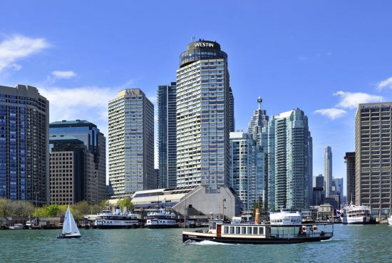

**WANO-MC**

**Governing Board**

**agenda**

**Toronto**

**Canada**

**4 October**

**2015**

| **4 October 2015** | | |
| --- | --- | --- |
| **Time** |  | **Responsible** |
| **9:45-13:30** | **WANO-MC Governing Board Meeting** |  |
| **9:45**  **10:00** | **WANO-MC Governing Board Chairman and Vice-Chairman Election** | **Peter Tuominen**  WANO-MC Nomination Committee Chairman |
| **10:00**  **10:05** | **Agenda Approval** | WANO-MC Governing Board Chairman |
| **10:05**  **10:15** | **Minutes Approval of the 66th WANO-MC Governing Board meeting** | WANO-MC Governing Board Chairman |
| **10:15**  **10:30** | **WANO’s activity from April till October 2015** | WANO-MC Governing Board Vice-President |
| **10:30**  **10:50** | **WANO’s activity from April till October 2015** | **Vasily Aksenov**  WANO-MC Director |
| **10:50**  **11:20** | **Moscow Centre long-term plan 2015-2019** | **Vasily Aksenov**  WANO-MC Director  **Sergey Frolov**  WANO-MC Deputy Director |
| **11:20**  **11:40** | coffee break |  |
| **11:40**  **11:50** | **Tender Commission results approval** | **Sergey Frolov**  Tender Commission Chairman  WANO-MC Deputy Director |
| **11:50**  **12:10** | **Changes in Moscow Centre regulatory documentation** | **Sergey Frolov**  WANO-MC Deputy Director  **Anatoliy Chukharev**  OSR Supervisor |
| **12:10**  **12:25** | **Changes in WANO-MC working plan and budget items for 2015** | **Vasily Aksenov**  Director  **Sergey Frolov**  WANO-MC Deputy Director |
| **12:25**  **12:40** | **Consideration and approval of WANO-MC working plan 2016** | **Vasily Aksenov**  Director  **Sergey Frolov**  WANO-MC Deputy Director |
| **12:40**  **12:55** | **WANO-MC Budget consideration and approval for 2016** | **Vasily Aksenov**  Director  **Sergey Frolov**  WANO-MC Deputy Director |
| **12:55**  **13:10** | **BGM information 2015** | **Sergey Frolov**  WANO-MC Deputy Director |
| **13:10**  **13:15** | **About the next WANO-MC Governing Board** | WANO-MC Governing Board Chairman |
| **13:15**  **13:30** | **Other** | WANO-MC Governing Board Chairman |