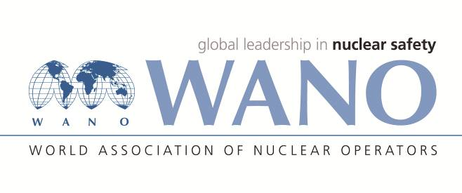 | Московский центр  Всемирная Ассоциация Организаций, эксплуатирующих Атомные Электростанции  ВАО АЭС – МЦ  Россия, 109507, Москва, Ферганская ул., 25  Тел. +7 495 376 15 87  Факс: +7 495 376 08 97  info@wanomc.ru

REQUEST
to provide technical and organizational information via WANO

- NPP/Organization:
Temelin NPP / CEZ Group
- The topic of information request:
Operation of motors of reactor coolant pump (RCP) for NPP VVER 1000
- The goal of information request:
Determination of reactor coolant pump (RCP) engine life
- Description of the problem:
The end of engine-declared engine life is approaching
- Questions:
RCP engines type VAZ-215 / 109-6AMO5 from the manufacturer "Uralgidromaš" are used at the Temelin NPP. Due to the approaching exhausted project life of engines (30 years), we are starting to prepare an event for their replacement. We request information on whether the motors of the main circulation pumps were replaced on a similar type of NPP at the time of their project life, or whether a decision was made on their further operation and how their condition was evaluated.
- Proposed organizations for sending this request:
VVER-1000 nuclear power plants
- Department – request initiator:
Administration - electrical systems, Project change engineering
- Contact details of the requester:
Petr Dědič, mob.: +420 606 805 876, e-mail: petr.dedic@cez.cz
Eduard Pudil, mob.: +420 602 470 038, e-mail: eduard.pudil@cez.cz

- Date of request:
15.10.2021

The request created by:
WANO MC on site representative at the Temelin NPP
Ing. Josef Hejdus
mobil: +420 792 330 242
e-mail: Josef.Hejdus@cez.cz

