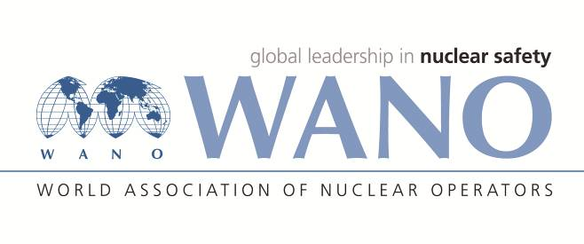 | World Association of Nuclear Operators  Moscow Centre  WANO – MC  25 Ferganskaya, Moscow, 109507, Russia  Phone. +7 495 376 15 87  Fax: +7 495 376 08 97  info@wanomc.ru

REQUEST
to provide technical and organizational information via WANO

- NPP/Organization: MVM Paks NPP
- The topic of information request: Certification requirements to fasteners built into systems of different safety classes.
- The goal of information request: Getting information from other plants regarding the topic of request.
- Problem description: -
- Specific questions:
What certification requirements apply to fasteners built into systems of different safety classes at your plant?
- Proposed organizations for sending this request:
All WANO regional centres
- Department – request initiator: Operating Experience Section
- Contact details of the requester: Zoltán VAJNA, head of Logostics Department; vajnaz@npp.hu
- Date of request: 14.02.2022

WIO at Paks NPP Jelena Hadnagy

