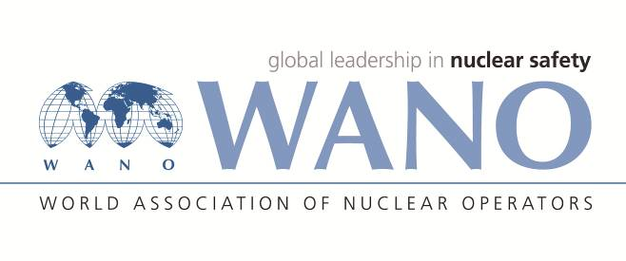 | WORLD ASSOCIATION OF  NUCLEAR OPERATORS  MOSCOW CENTRE  WANO – MC  25 FERGANSKAYA, MOSCOW, 109507, RUSSIA  Phone: +7 495 376 15 87  Fax: +7 495 376 08 97  info@wanomc.ru

REQUEST
to provide technical and organizational information via WANO

- NPP/Organization: Fortum Power and Heat Oy, Loviisa NPP

- The topic of information request:
Drums for final storage
- The goal of information request:
To know what kind of type final storage drums/barrels other nuclear plants uses. Important features of the barrel are the barrel dimension, the coatings and materials, and the price estimate.
- Problem description:
The aim is to find out how much new and stronger disposal barrels would cost to acquire.
- Specific questions:

1. Barrel dimensions; Height, diameter, wall thickness?

2. Barrel material and coating?

3. Barrel supplier and manufacturer?

- Proposed organizations for sending this request:
- NPP's in WANO MC
- Department – request initiator:
- Nuclear Plant Waste
- Contact details of the requester:
Veera Mannikko, Loviisa NPP, Finland
email: Veera.Mannikko@fortum.com
- Date of request: 10.6.2021

