

Project INSC IRN3.01/16 Lot 2  
Support in the stress tests exercise

Monthly Report

Reporting period: April 2019

Contractor's report number IRN3.01/16/MR-012

Revision 0°, 16 May 2019

INSC Contract No. 2017/387-889

Prepared by:

|  |  |  |  |
| --- | --- | --- | --- |
| Organization | Name | Signature | Date |
| The Contractor | Jiri Sedlak |  | 16 May 2019 |

Approved by:

|  |  |  |  |
| --- | --- | --- | --- |
| Organization | Name | Signature | Date |
| The Contractor | Jozef Misak |  | 20 May 2019 |

Terms of Content

1. Progress of activities 3

2. General assessment of the progress 3

3. Completed milestones during reporting period 3

4. Milestones to be completed during next reporting period 4

5. Problems encountered during reporting period 4

6. Foreseen deviations to the time schedule 4

7. Recommendations and requests 4

8. Attachments - minutes or reports from official meetings (if relevant) 4

# Progress of activities

Effort was concentrated on preparation and efficient course of the Consultancy Meeting. The main goal of the meeting was to gather all the information and pieces of previously agreed text from the End-user, which were not able to be obtained electronically as promised during the Technical meeting in February. Even if some parts of the text were sent to UJV couple days prior to the consultancy meeting, they contained only limited amount of new information if any.

The first Consultancy Meeting (CM1) was held at the NPPD company premises in Tehran, in the period 29th to 30th April 2019. Besides 5 UJV experts (WGs 1-3 leaders accompanied by one expert in floods and one nuclear expert), the meeting was attended by 3 specialists from NPPD and 7 specialists from Tavana (for details see MoM in the Attachment). Some gaps in required information were filled in during the meeting and comments and requests previously sent to the End-user were discussed face to face. The missing data and text were promised to be sent to UJV asap.

# General assessment of the progress

The progress of the project slightly suffers from less involvement of the End-user specialists compared to what had been agreed during the previous meeting. To mitigate the situation, the Contractor team is encouraging the End-user specialists to intensify their efforts on one hand and takes over part of their work on the other hand.

# Completed milestones during reporting period

None.

# Milestones to be completed during next reporting period

None.

# Problems encountered during reporting period

Problems with missing inputs as described in paragraph ‎1.

# Foreseen deviations to the time schedule

Measures have been adopted to minimize the delay in the work schedule. The draft of the self-assessment report is intended to be finalized prior to the June Technical Meeting in Iran to be discussed there, and subsequently a decision regarding future Action Plan to be made based on that discussion. However, due to the lack of support data, some particular recommendation will not be as specific as it had been hoped and some calculations and analysis will be moved into the implementation phase. The Action Plan still could be on the same level of details as those of EU countries in the past. This approach seems to be preferable than to delay the SAST report more by perfecting the text.

# Recommendations and requests

The recommendation is to intensify the works and to send all the important inputs from the End-user to the Contractor asap.

# Attachments - minutes or reports from official meetings (if relevant)

MoM of the Consultancy Meeting.

Instrument for Nuclear Safety Cooperation

Project INSC IRN3.01/16 Lot 2

**SUPPORT IN THE STRESS TEST EXERCISE**

**MEETING MINUTES**

**Consultancy Meeting for SAST Report (Task 2)**

29.4.-30.4.2019, NPPD, Tehran, Iran

List of contents

1. Place and time 3

2. Attendance: 3

3. Course of the workshop 4

4. Presentations delivered during the workshop 4

5. Works in working groups 4

6. NPP documents handed over during the workshop 4

7. Attachments 5

Attachment 1 Agenda of the workshop 5

Attachment 2 List of participants 6

Attachment 3 Additional Requirements for information b 7

Attachment 4 Presentations 7

# Place and time

Consultancy Meeting organized in the framework of the Project INSC IRN3.01/16 Lot 2 “Support in the Stress Test Exercise” was held in the NPPD company premises in Tehran, Iran in the period from 29th to 30th April 2019.

# Attendance:

**NPP:**

Mr. Musa Bahrani

Mr. Saheb Mehrafshan

Mr. Vahid Momeninia

**TAVANA (TSO to NPPD):**

Mr. Mohammad Hossein Raji, Head of Nuclear Engineering dpt.

Mrs. Elham Tavakoli, Head of DSA section

Mr. Mohamad Rezaee

Mr. Ali Akbar Najafi

Mr. Amin Golestani

Mr. Shahram Sheikhi

Mr. Mehran Sirouspoor

**UJV:**

Mr. Stanislav Hustak, Key-expert

Mr. Jan Maly, Key-expert

Mr. Jozef Balaz, Senior expert

Mr. Jan Stanicek, Junior expert

Mr. Milan Krivda, Junior expert

# Course of the meeting

At the beginning of the meeting UJV presented the status of activities in each WG. Then the particular working groups worked separately. The status of the particular parts of the SAST report to be elaborated by TAVANA and to be elaborated by UJV was identified and discussed.

WG2:

Sections 5.1.1÷5.1.3 and 5.2.1÷5.2.3 of SAST report provided to TAVANA at 1st of March have not been updated so far. UJV comments and suggestions as well as available BNPP/TAVANA responses to them were discussed. Some missing responses were provided by TAVANA, the remaining ones shall be provided to UJV by 6th of May. The Chapter 5 will be completed by UJV.

For WG1 and WG3 see Attachment 3.

# Presentations delivered during the workshop

The following presentations were given during the workshop.

* Presentation of Summary of Activites - WG1
* Presentation of Summary of Activites - WG2
* Presentation of Summary of Activites - WG3

All presentations are included in Attachment 2.

# Works in working groups

The meeting attendees were split down into working group for discussions in parallel sessions.

Table 1 Working groups breakdown

| WG-1 | WG-2 | WG-3 |
| --- | --- | --- |
| Maly | Hustak | Balaz |
| Stanicek | Tavakoli | Mehrafshan |
| Krivda | Golestani | Sheikhi |
| Raji |  | Bahrani |
| Momeninia |  |  |
| Najafi |  |  |
| Rezaee |  |  |
| Sirouspoor |  |  |

# NPP documents handed over during the workshop

See minutes of particular WGs (‎Attachment 3).

# Conclusions

Some missing information was gathered and required content of some pending parts of the self-assessment report in charge of the End-user were clarified. A significant effort of the End-user specialist in the near future is expected to fill in gaps in the text.

New versions of the respective subchapters were promised to be send to UJV as well as missing data. Deadlines and responsibility are defined in the minutes of individual working groups (see ‎Attachment 3).

The deadline for sending updated chapters 2, 3 and 4 (WG1) to UJV is May 12. Missing answers for Q&A (WG2) are expected to be send to UJV on May 6 at the latest.

The draft of the remaining chapters 6.2 and 6.4 (WG3) is to be compiled by TAVANA and send to UJV within 2 weeks.

Updated Chapter 1 of SAST Report will be sent to UJV by 10th of May.

# Attachments

1. Agenda of the workshop

1. List of participants

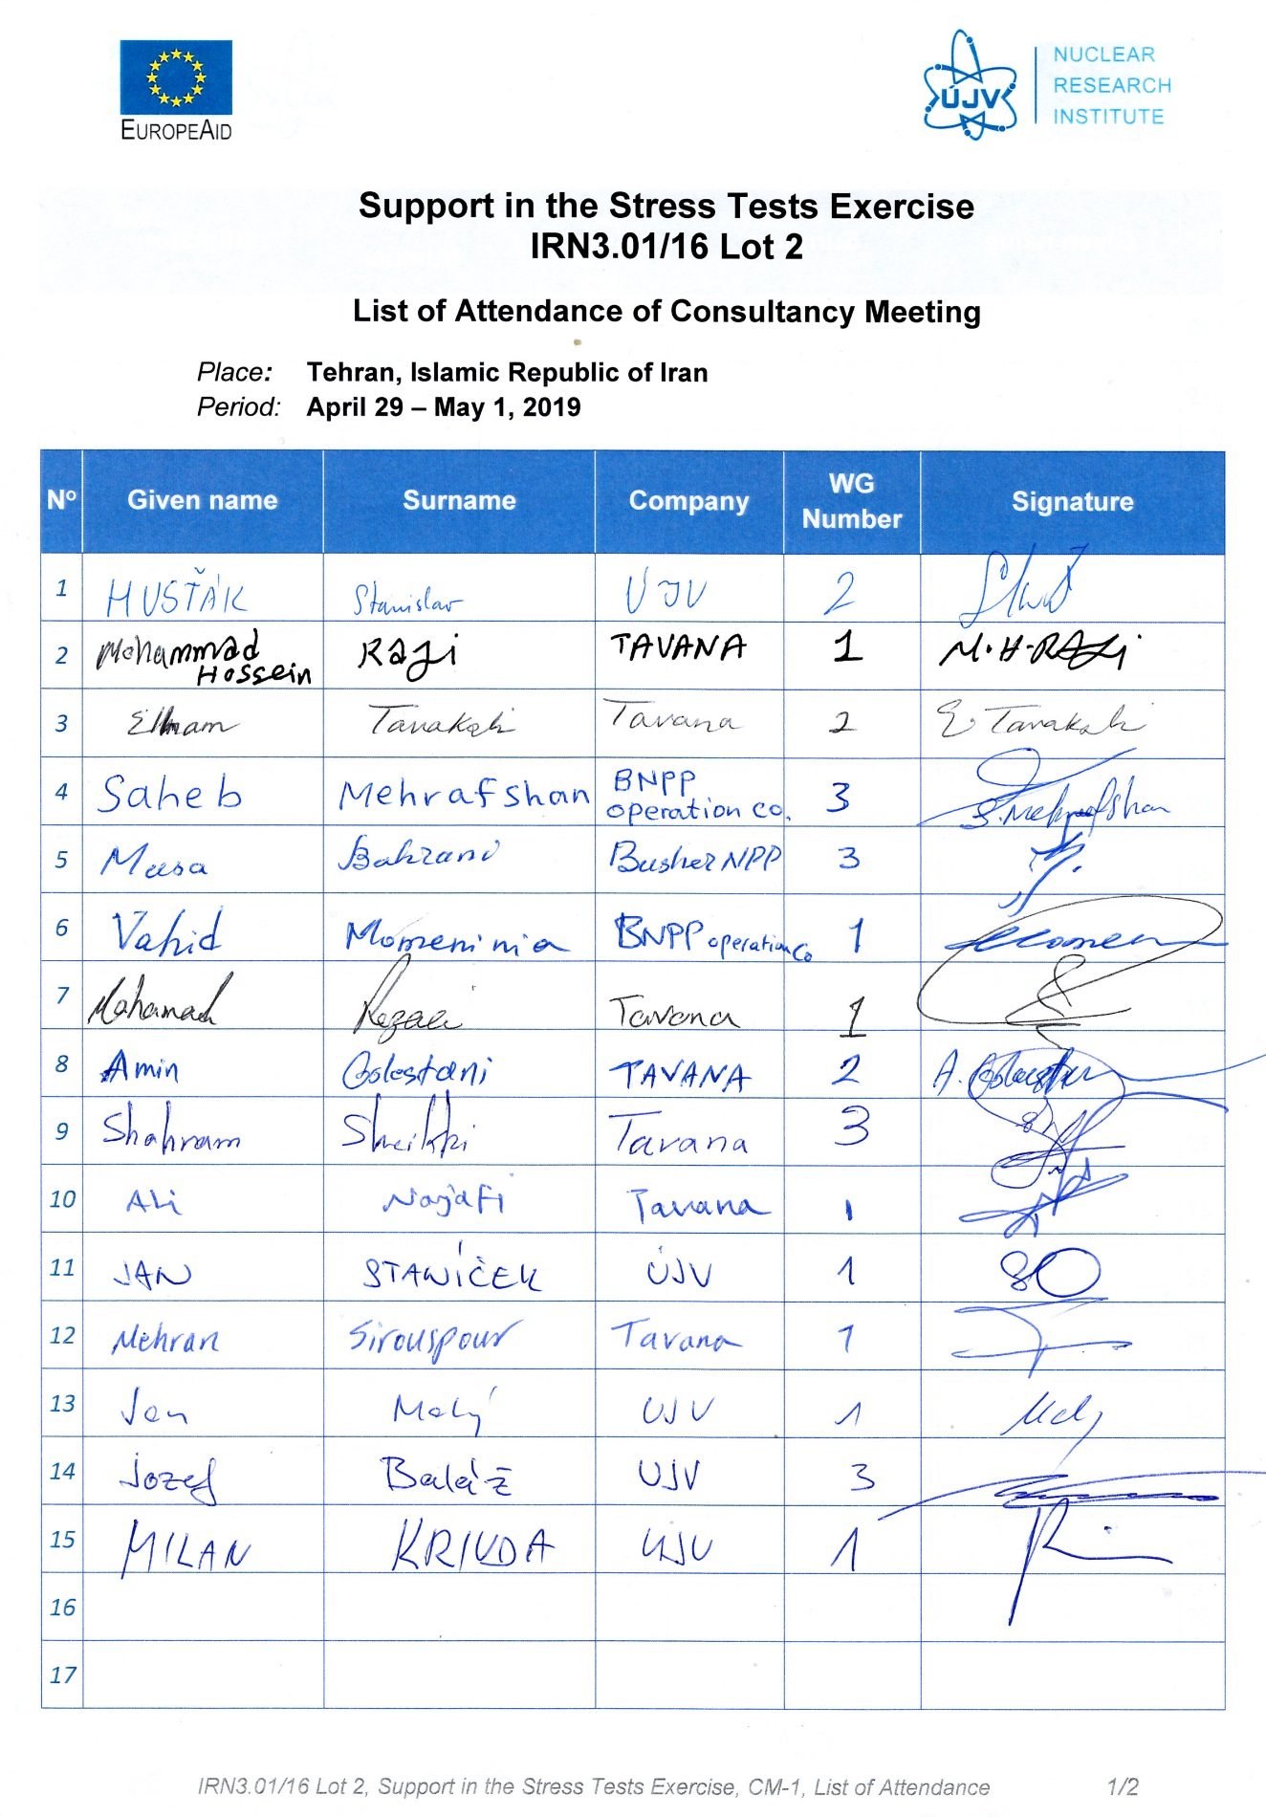

1. Additional Requirements for information

WG-1



WG-2



WG-3



1. Presentations







