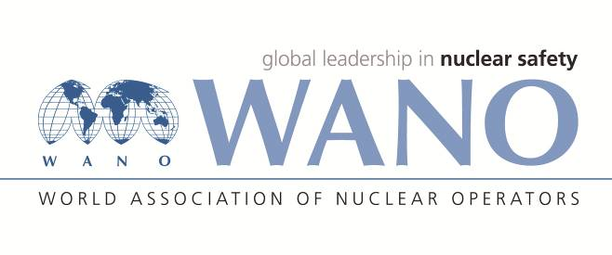 | World Association of Nuclear Operators  Moscow Centre  WANO – MC  25 Ferganskaya, Moscow, 109507, Russia  Phone. +7 495 376 15 87  Fax: +7 495 376 08 97  info@wanomc.ru

REQUEST
to provide technical and organizational information via WANO

- NPP/Organization: MVM Paks NPP
- The topic of information request: Implementation of the 1.a recommendation of SOER 2010-1 “Shutdown Safety”.
- The goal of information request: We would like to receive information from WANO members about their positive practices regarding the implementation of 1.a recommendation of SOER 2010-1 “Shutdown Safety”.
Problem description: Paks NPP would like to supplement the existing outage safety analysis process with introduction of some kind of outage index or decay heat removal indicator.
- Specific questions:
      - How do you ensure the shutdown safety as a top outage priority? The 1.a recommendation of the SOER 2010-1 requires defining the shutdown safety as a key success factor and outage goal. Please provide practical example, solution.
      - What kind of method or performance indicator is established and used for events that result in a loss of decay heat removal, challenge a shutdown safety function, or result in an unplanned increased risk condition?
- Proposed organizations for sending this request:
All WANO centres (AC, PC, MC, TC)
- Department – request initiator: OE Section
- Contact details of the requester: Jelena Hadnagy, Senior Engineer, hadnagyj@npp.hu
- Date of request: 26.07.2021

WIO at Paks NPP Jelena Hadnagy

