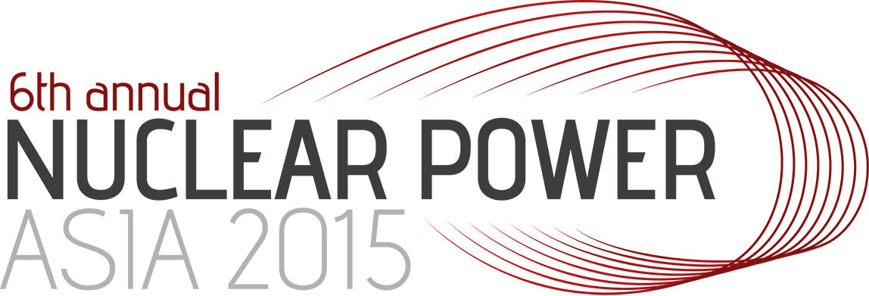
27-28 January 2015, Kuala Lumpur Malaysia

I, __Naser Rastkhah___________ Passport No. _D9012082_______________________ hereby confirm that I will be attending the 6th annual Nuclear Power Asia 2015 taking palce at Hilton Kuala Lumpur on 27th & 28th.

I ask the organiser Clarion Events to reserve the rooms for myself and my colleague at the Hilton hotel and I will make the payment to the hotel when I arrive. I understand and accept that Clarion Events will invoice me the hotel fees to me in case we are not showing up at the hotel.

Speaker Name: ____Naser Rastkhah___________________

Signature:
Date:

