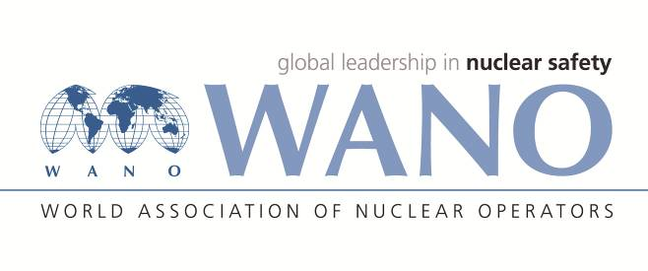 | World Association of Nuclear Operators  Moscow Centre  WANO – MC  25 Ferganskaya, Moscow, 109507, Russia  Phone. +7 495 376 15 87  Fax: +7 495 376 08 97  info@wanomc.ru
REQUEST
to provide technical and organizational information via WANO

- NPP/Organization: Jiangsu Nuclear Power Corporation, Tianwan NPP
- The topic of information request:
Concerning of the defects of VVER stem generators
- The goal of information request:
We hope to know the treatment methods of the defects of the dissimilar weld joints at the steam generator of the VVER unit, the corrosion situation and treatment method of the primary-side air vent pipelines and leakage monitoring pipelines within the interior of steam generators.
- Problem description:
According to some foreign experience feedback, we have learned that in some VVER plants of several countries, cracks were always found in the dissimilar weld joints of steam generators with the material of 22K+08X18H10T, such as emergency feed water nozzle, blowdown nozzle, etc, as is shown in figure 1. After preliminary combing, there are dozens of similar dissimilar weld joints of VVER-1000 steam generator nozzles in Tianwan NPP. There for, in order to prepare the processing plan in advance, it is necessary to further understand the processing methods of defects.
The primary-side air vent pipelines and leakage monitoring pipelines within the interior of VVER steam generators are made of carbon steel, which is easily damaged by the corrosion of the boric acid solution. To assure the safety of steam generators, we need to understand the situation and treatment measures of corrosion leakage.
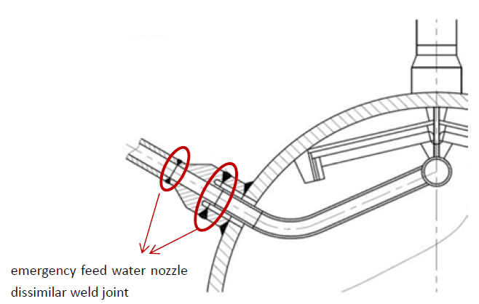
图1 缺陷位置示意图
Figure 1 Schematic diagram of defect location
- Specific questions:
1) How to deal with the cracks with these dissimilar weld joints?
2) We learned that the damaged dissimilar weld joints were repaired in accordance with item 142 of НП-104-18, using factory-made adapters. Have you adopted this method? If so, whether these adapters must be made by the steam generator factory? Whether the NPPs could make the adapters themselves?
3) Whether specific method such as weld overlay was used for repairing?
4) Whether damages were ever found on the air vent pipelines, leakage monitoring pipelines and other pipelines connecting the nozzles in other VVER plants, and how to deal with it?
- Proposed organizations for sending this request:
WANO-MC NPPs. Focus on consulting NPPs in Russia.
- Department – request initiator:
Engineer of Technical support department, Tianwan NPP.
- Contact details of the requester:
Xu Xinzhu, Engineer of Technical support department
Tel. (office): +86 518 82245394
E-mail. xuxz@cnnp.com.cn
- Date of request: 30.09.2021

