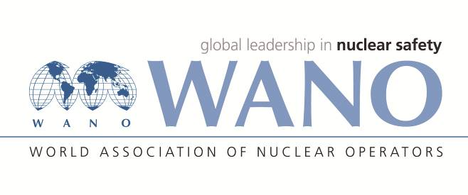 | World Association of Nuclear Operators  Moscow Centre  WANO – MC  25 Ferganskaya, Moscow, 109507, Russia  Phone. +7 495 376 15 87  Fax: +7 495 376 08 97  info@wanomc.ru
REQUEST
To provide technical and organizational information via WANO

- NPP/Organization: Kudankulam NPP

- The topic of information request:
pH value at 25 Deg C and Ammonia concentration in blow down sample from salt compartment & bottom blow down of Steam Generator (SG), when plant is operating at full power.
- The goal of information request: Getting relevant information from operating VVER-1000 plants
4. Problem description:
KKNPP is observing that pH at 25 Deg C of Steam Generator salt compartments blow down water is in the range 8.8 – 9.0 against the specified limit of 9.0 – 9.5 at full power. Ammonia is used as alkalizing medium for secondary circuit.
5. Specific questions:
- What is the pH at 25 Deg C and Ammonia concentration for the following sample of VVER plant?

Sl.No | Sampling point | pH at 25 Deg C | Ammonia (µg/Litre)
 | Condensate water
 | Discharge of Condensate extraction pump #2
 | Deaerator water
 | Feed water after High Pressure Heater
 | SG blow down from salt compartment
 | SG blow down from bottom blow down
 | SG Steam

- SG salt compartment blow down rate and periodic line blowdown rate?
- Mode of continuous and periodic blowdown?
- How many SG blowdown purification filters LCQ71-74 in service?
- What is the purification flow through LCQ71-74 filter?

6.Proposed organizations for sending this request:
NPPs of WANO-MC having VVER type of units
7.Department – request initiator: Technical Services, Kudankulam NPP
9.Contact details of the requester:
Sanjeev Bhardwaj , WANO-MC contact Person +91-9489080628,
Email : sbhardwaj@npcil.co.in
10.Date of request: 06.07.2020

