PERSONAL DATA

FOR APPLICATION FOR ENTRY VISA TO

THE ISLAMIC REPUBLIC OF IRAN
___________________________________________________

IAEA Project No.: IRA2011 17

- Full Name: Kamenov, Krasimir Mitkov

- Sex: Male

- Date of birth: 18 March 1967

- Place of birth: Belogradchik, Bulgaria

- Nationality: Bulgarian

- Father’s name: Tzakov, Mitko Kamenov

- Country of residence: Bulgaria

- Name and address of organization: Kozloduy NPP Plc., 3321 Kozloduy, Bulgaria

- Telephone: +359 973 7 37 75

- Fax: +359 973 8 05 91

- Email: K_Kamenov@npp.bg

- Passport number (please attach a photocopy of the first pages of your passport): 380087780

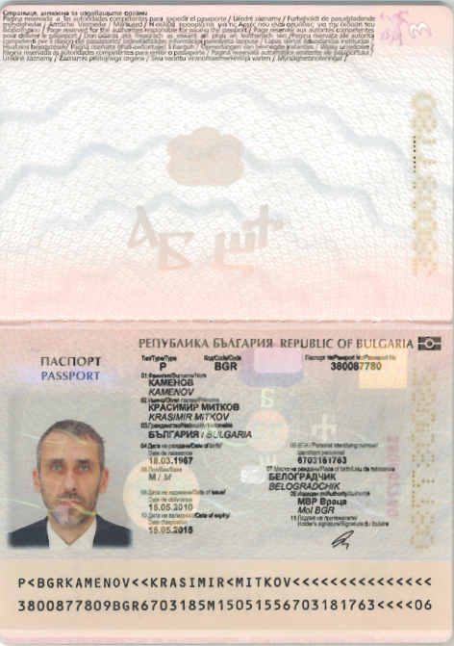

- Date of issue: 15.05.2010

- Place of issue: Vratsa, Bulgaria

- Valid until: 15.05.2015

- Place where entry visa to Iran will be applied for (Iranian Embassy/ Consulate): Sofia, Bulgaria

- Dates of last entry to Iran: -

Please complete this form and send via email or fax to:

Eric Boghos-Schababian
Division for Asia and the Pacific
Department of Technical Cooperation
International Atomic Energy Agency

Email: e.boghos@iaea.org
Fax: 0043 1 26007

