# Earthquakes

The main objective of this review is to demonstrate that the design basic earthquake was determined in a state-of-art manner and provides trusted information about the resistance of the Bushehr NPP to seismo-tectonic hazards and about the existence of a sufficient safety margin.

## Design basis

### Earthquake against which the NPP is designated

In this chapter are assessed three issues:

1. Characteristics of the design basis earthquake (DBE);
2. Methodology used to evaluate DBE;
3. Adequacy of DBE.

#### Characteristics of the Design Basis Earthquake

As can be seen from the FSAR text, seismic hazard (resp. SL-2 value) was determined using three approaches, macroseismic, deterministic and probabilistic (See report 49.BU.1 0.0.ОО.FSAR. RDR001, Moscow, 2011 / Table 2.5.2.6-6). See Table 1.

Table 1: The mean PGA estimations for the BNPP site (SL-2)

|  |  |  |
| --- | --- | --- |
| Method | PGHA, *g* | PGVA, *g* |
| Macroseismic | 0.40 | 0.22 |
| Deterministic (DSHA) | 0.40 | 0.22 |
| Probabilistic (PSHA) | 0.40 | 0.20 |
| Mean rounded | 0.40 | 0.22 |

According to IAEA standard that applied at the time (NS-G-3.3, par. 5.3), they were evaluated two levels of ground motion hazard, here named SSE (i.e. SL-2) and DBE (SL-1). SSE and DBE values for Bushehr NPP are listed in the “Report on safety analyses of Bushehr NPP at extreme external impacts” (Moscow, 2012). See Table 2 and Table 3.

Table 2: Expected parameters of strong ground movements for SSE.

|  |  |  |  |  |  |
| --- | --- | --- | --- | --- | --- |
| Zone PSC | Peak Acceleration | | Duration *d*+*σ*, sec | Zero period*T0*, sec; σ, un.log. | spectrum width *S*+*σ*, un.log. |
| PGHA, *g* | PGVA, *g* |
| Delvar-Ahram | 0.40 | 0.22 | 3.1 | 0.15; 0.12 | 0.78 |
| Delvar-Mand | 0.35 | 0.18 | 6.6 | 0.21; 0.12 | 0.78 |
| Borazjan -KazerunII | 0.27 | 0.14 | 18.2 | 0.32; 0.12 | 0.78 |
| Diffused seismicity | 0.36 | 0.21 | 2.3 | 0.13; 0.12 | 0.78 |

Table 3: Expected parameters of strong ground movements for DBE.

|  |  |  |  |  |  |
| --- | --- | --- | --- | --- | --- |
| Zone PSC | Peak Acceleration | | Duration *d*+*σ*, sec | Zero period *T0*, sec; σ, un.log. | spectrum width *S*+*σ*, un.log. |
| PGHA, *g* | PGVA, *g* |
| Delvar-Ahram and diffused seismicity | 0.20 | 0.10 | 2.1 | 0.12; 0.12 | 0.78 |

#### Methodology used to evaluate the design basis earthquake

This section discusses the procedures, the methods used to evaluate DBE and the results of this evaluation from the point of view of current requirements and state-of-art approaches. Gradually all the steps of seismic hazard analysis, as specified in the assignment, are discussed.

Site geology and tectonics

The description of the geology of the NPP and Bushehr site has been made in sufficient detail and addresses all significant geological and tectonic phenomena (See Report 49.BU.1 0.0.ОО.FSAR.RDR001, Chapter 2.5.1). Evaluation of the site vicinity is based on the division of this area into surface morphogenetic units for which the following parameters were determined: characteristic of underlying soils, groundwater level depth, evolution of the recent physical and geological processes; and also the active tectonic features were mapped. Site vicinity faults were searched using seismic profiling, as shown, e.g. in the Section 2.5.1.1.4 Geophysical Study Results.

The geology and tectonics were evaluated in accordance with the IAEA NS-G-3.3 standard that was in force at that time. Also, the recommended field survey methods were used and near regional faults were identified.

The results of the geological investigation are recorded in the FSAR. However, there can be found some weaknesses, especially in the details of the description and documentation of the evidences. Missing particularly comprehensive table of faults where the identified faults would be described in terms of their parameters (age, length, dip, slip rate, type of faulting, etc.) and estimation of the age of the last movements.

It is also necessary to take into account that the requirements for investigating faults in the vicinity of nuclear facilities have increased in the last decade. Similarly, research methods have improved a lot.

According to current practice, if a capable fault is detected in the site vicinity of the NPP candidate site, IAEA recommends the consideration of an alternative site. It should be noted that capable faults may be found in existing site, too. In such a case, IAEA recommends evaluating the safety using fault displacement hazard assessment (FDHA). In any case, it is necessary to collect information about faults in the near region and site vicinity (in terms of Section 3 of the IAEA standard SSG-9) in order to exclude (or confirm) the presence of a capable fault in the site vicinity.

In the present state of knowledge about the site, additional investigations, including the requirements of the IAEA Standard SSG-9 (2010) as well as the WENRA document (10/2015), must be recommended. In particular, two analyzes must be completed at least:

1. Analysis of the digital model of relief (DMR) for the NPP near region in order to identify morpho-lineaments and to check faults that have been detected by geophysical methods.
2. Checking suspicious morpho-lineaments and faults using paleo-seismological research (trenching, drilling etc). See IAEA standard SSG-9 (2010), par. 8.6 or TECDOC-1767 (2015).

Database of seismological data and their analysis

Although the requirement to create a seismic database is not explicitly stated in the IAEA standard NS-G-3.3, the standard recommends collecting “seismic data and historical earthquake records” in par. 2.26.

These data, i.e. earthquake catalogue for the period 840-1899 and 1900-1999, are presented in the report 9S.BU.l 0.0.IZ.PM.PRR041 (Tehran, 1999) and later in the FSAR (report 49.BU.1 0.0.ОО.FSAR. RDR001, Moscow, 2011).

Historical and paleo earthquake epicenter are shown in Figure 2.5.2.1-1 in the report 49.BU.1 0.0.ОО.FSAR. RDR001 (Moscow, 2011). See Fig. 1. The picture shows that the paleo earthquake data was also collected. This data was used to identify source zones, one of the criteria being a relation to the epicenters of instrumental and historical earthquakes, relations to manifestations on archaeological monuments and paleoseismicity.

Fig. 1 depicts the epicenter of the nine paleo earthquakes, but it is not clear whether these are sites with damaged archaeological monuments or geological records of paleo earthquakes unearthed in the trenches. Then, it is impossible to determine how the magnitude of these earthquakes has been estimated.

The procedures of the seismic data analysis can be considered as standard, corresponding to the available methods of that time. The solution also meets the requirements of the current IAEA standard SSG-9 (2010) where, according to par. 3.24 is required “Information on prehistorical, historical and instrumentally recorded earthquakes in the region shall be collected and documented.” However, the time gap from the analysis, unfortunately, could burden the result with additional epistemic uncertainties.

It is necessary to supplement the earthquake catalogue with data from the years 1999-2019, as the catalog is just ending in 1999. It is also necessary to clearly clarify the paleo earthquake data, whether it is an "archeo" or "paleo" earthquake, and also to clarify way of the magnitude estimation.

The issue of earthquake catalogs is associated with several discrepancies in the FSAR text (report 49.BU.1 0.0.ОО.FSAR. RDR001). The text of Figure 2.5.2.1-4 indicates that the figure shows 606 epicenters. However, only 90 events are recorded in Table 2.5.2.1-4, with explanation that only perceptible earthquakes (M> 3.5, I> 3 points) being selected. Unfortunately, it is not clear what is meant by the term "perceptible".

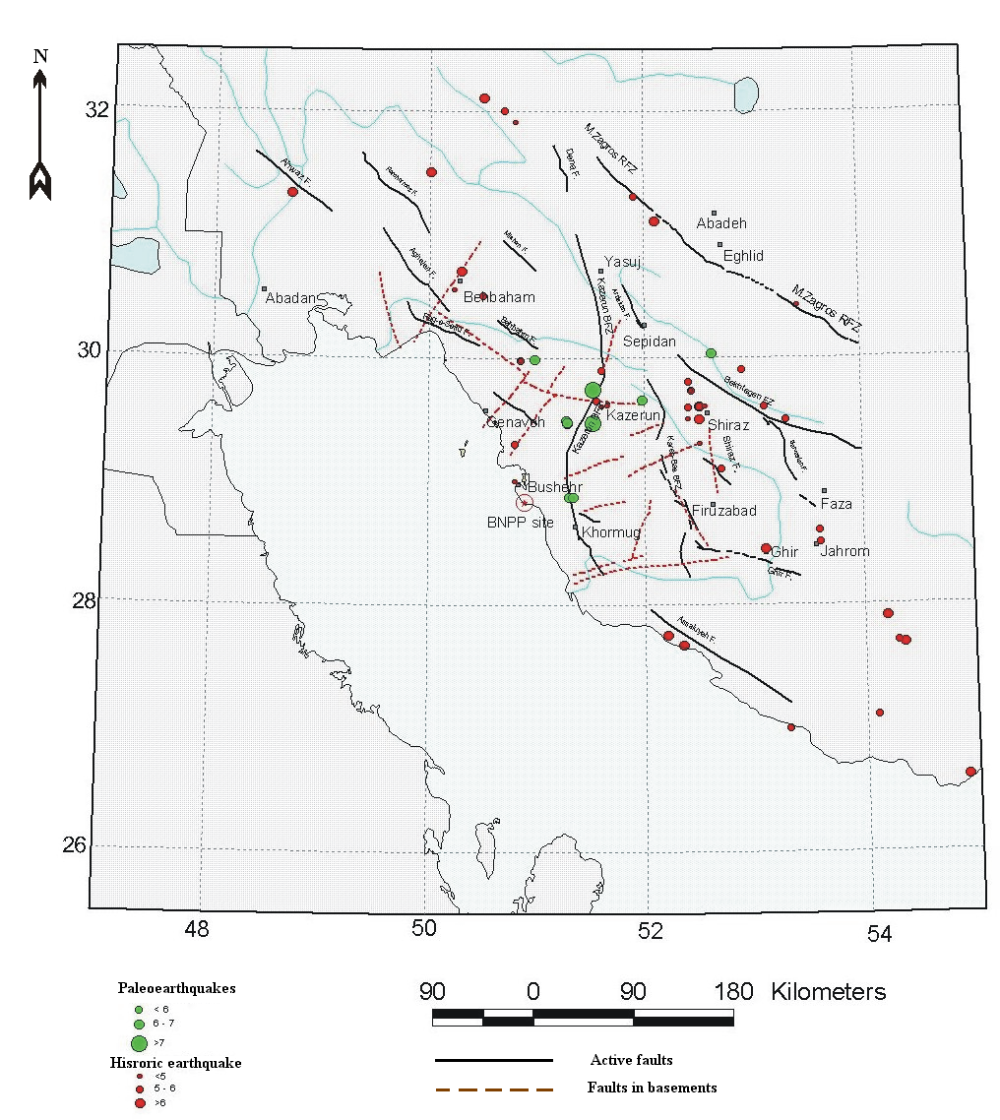Fig. 1: Map of historical and paleo earthquake epicenters.

In Figure 2.5.2.1-4, 3 epicenters with magnitudes 3-4 are plotted near the NPP, but these epicenters are not listed in Table 2.5.2.1-4. This should be seen as an example of more serious discrepancies. See Fig. 2, blue arrows.

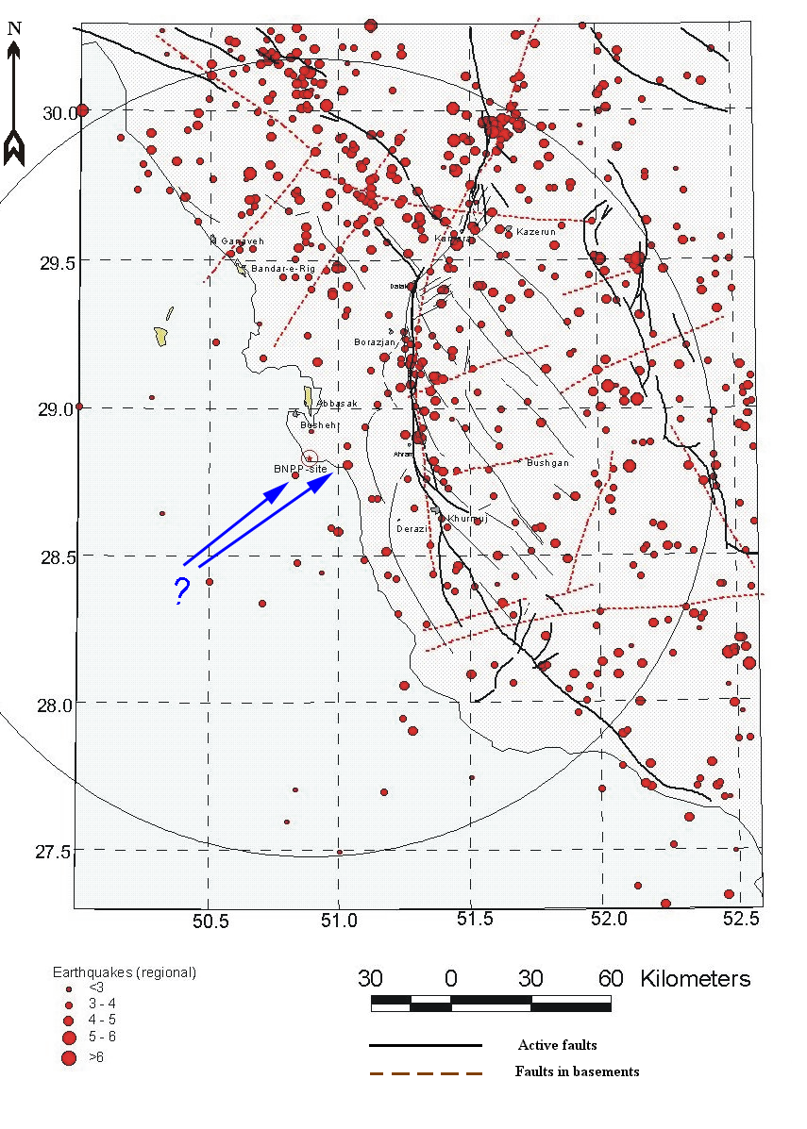Fig. 2: Epicenter map of earthquakes. Data from the regional catalogue (1900-1999). The blue arrows show an example of discrepancies.

Identification of the seismic sources – seismotectonic models

The definition of seismic sources is based on two seismotectonic models, areal source zones and fault zones (See Fig. 3). Zone delineation was based on the analysis of seismic and tectonic information and 150 km region is considered, as it had been required by the IAEA standard NS-G-3.3. The definition of source zones seems to be logical, the source area with background (diffuse) seismicity is not omitted in the model.

It should be noted that the currently valid IAEA standard SSG-9 (2010) requires in the par. 3.7 evaluation of the region of 300 km. It does not seem very likely that this expansion of the region will result in a significantly different resulting seismic hazard.

Also, in case of seismotectonic models, discrepancies can be detected.

From the FSAR text, the Delvar-Ahram, Borazjan-Kazerun and Delvar-Mand source zones are the most contributing to the seismic hazard of the Bushehr NPP. Clear and understandable is the definition of the Borazjan-Kazerun source zone (BK I/II/III). The outline of the zone fits both to the plot of the fault branches and envelops the earthquake epicenter clusters. Also, the segmentation of this fault seems to be justified.

On the other hand, the argumentation concerning the Delvar-Ahram zone is somewhat poor. Nowhere is it possible to find drawing of the Delvar-Ahram fault (even not in Fig. 2.5.2.1-6), even though it is described in the text (See report 49.BU.1 0.0.ОО.FSAR. RDR001, p. 105). Further, the earthquakes that are attributed to this fault are not clearly specified anywhere. Also, the fault Delvar-Mand (DM) is described poorly.

It is necessary to deepen the description of the key seismic source zones in order to make it clear how the parameters of these zones, such as constants of the GR law and the maximum magnitude, have been derived.

The number of recorded earthquakes and the maximum observed magnitude for each zone is very important knowledge that cannot be missed. For such a significant zone as Delvar-Ahram, it would be very beneficial if there was evidence based on the outcome of paleoseismological research.

Determination of DBE

As required by the IAEA standards /NS-R-3 (2016), SSG-9 (2010)/, seismic hazard assessment (SHA) must be based on evaluation of the seismological and geological conditions in the region and the engineering geological aspects and geotechnical aspects of the proposed site area.

The choice of method for determining seismic hazard results from par. 5.1 The IAEA Standard SSG-9 (2010), which states "The ground motion hazard should preferably be evaluated by using both probabilistic and deterministic methods of seismic hazard analysis. When both deterministic and probabilistic results are obtained, deterministic assessments can be used as a check against probabilistic assessments in terms of the reasonableness of the results, particularly when small annual frequencies of exceedance are considered.”.

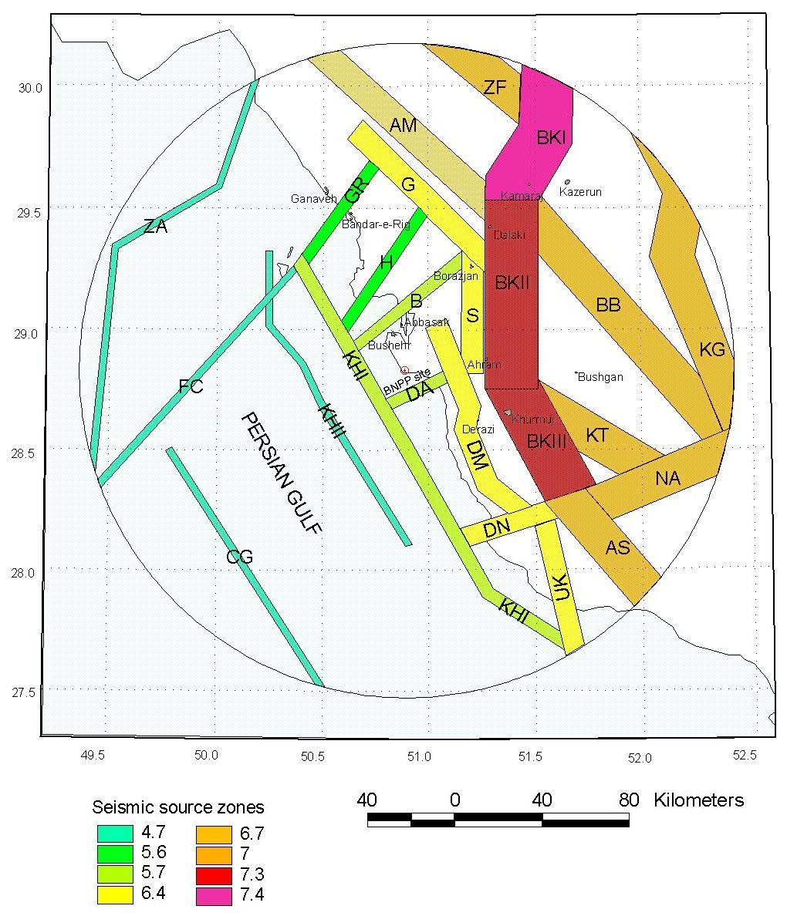

Fig. 3: Seismic source zones (Fault Model).

At present, a probable approach is preferred in a number of countries. A typical output from SHA should contain:

* Mean and fractile (0.05, 0.16, 0.50, 0.84 and 0.95) hazard curves;
* Mean and fractile uniform hazard response spectra for annual frequencies of exceedance of 10−2, 10−3, 10−4, 10−5 and 10−6 and for fractile levels of 0.05, 0.16, 0.50, mean, 0.84 and 0.95;
* Treatment of uncertainties;
* Seismic source deaggregation;
* Time histories;
* Local conditions.

As mentioned above, three approaches were used to determine DBE: macroseismic, deterministic and probabilistic (See report 49.BU.1 0.0.ОО.FSAR. RDR001, Moscow, 2011 / Table 2.5.2.6-6). See Table 4.

Table 4: SL-2 values determined using different approaches.

|  |  |  |
| --- | --- | --- |
| Method | PGHA, *g* | PGVA, *g* |
| Macroseismic | 0.40 | 0.22 |
| Deterministic (DSHA) | 0.40 | 0.22 |
| Probabilistic (PSHA) | 0.40 | 0.20 |
| Mean rounded | 0.40 | 0.22 |

The fact that 3 different approaches have been used has to be assessed positively. However, it is strange that the same (almost equal) value was determined by all methods.

Hazard curves and levels of ground motion hazard

In accordance with the recommendation of par. 9.1 IAEA Standard SSG-9 (2010), two levels of ground motion hazard, here named SSE and DBE, are defined as earthquake design basis for the Bushehr NPP. These values were determined using PSHA method – See Report 18.BU.1 0.0.OO.VAB.PR (Moscow, 2009).

For the level of Maximum Design (Safe Shutdown) Earthquake (SSE):

0.4 g – in horizontal direction, resp.

0.26 g – in vertical direction.

For the level of Design Basis Earthquake (DBE):

0.2 g – n horizontal direction, resp.

0.1 g – in vertical direction.

The values were determined for probability of being exceeded of 1 x 10-2 (DBE value), resp. 1 x 10-4 (DBE value).

*Note: These values represent a conservative estimate of both levels since they were derived from the 84th fractile hazard curve, as shown by the report 18.BU.1 0.0.OO.VAB.PR. In many countries, 50th (median) fractile or mean value is used (See IAEA Standard NS-G-1.6, par. 2.3), depending on the requirements of the regulatory body.*

As can be seen from the text of the report 18.BU.1 0.0.OO.VAB.PR (Moscow, 2009), PSHA was performed in a standard way, including dealing with uncertainties. Work would benefit if curves were presented in the usual way, i.e. curves for mean and 0.05, 0.16, 0.50, 0.84 and 0.95 fractiles. Then there would be a clear degree of epistemic uncertainty in the seismic hazard analysis.

Response spectra

FSAR and other documents show that the response of Bushehr's site to seismic load was also evaluated (See report 49.BU.1 0.0..FSAR.RDR001, Moscow, 2011, Book2, p. 127 -).

The response spectra were developed using two methods, standard and so called “site specific”, as recommended at the time the valid standard IAEA NS-G-3.3 (par. 5.9). For the construction of the response spectra with different damping (2, 5, 7, 10 and 20 %), empirical relations between the maximum level of response spectrum and maximum ground acceleration were used. “Site specific” spectra were developed for for Delvar-Ahram, Delvar-Mand Borazjan-Kazerun II seismic zones in the epicentral distances 8, 16 and 36 km from the site.

In Fig. 2 below is shown the comparison of expected spectra calculated using the standard and “site specific” methods. As it could be observed from these figures, results obtained using different methods are in a good agreement with each other.

At present, a uniform hazard response spectrum (UHRS) is used to analyze the seismic response (See IAEA standard SSG-9, 2010, par. 9.4). UHRS is developed by selecting the values of the response spectral ordinates that correspond to the annual frequencies of exceedance of interest from the seismic hazard curves. And it is possible to use the data from Next Generation Attenuation (NGA) Models.

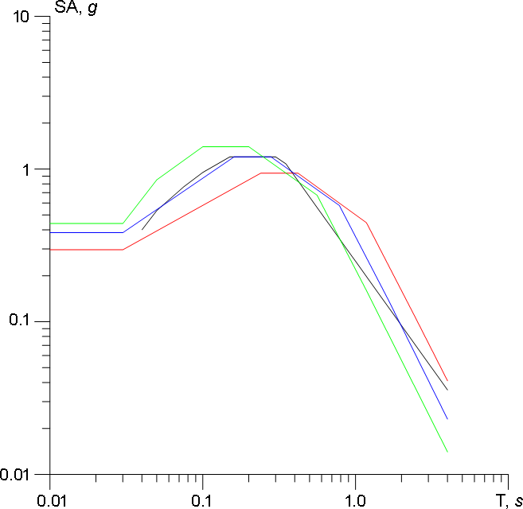

Fig. 5: Comparison of expected spectra obtained by standard method (black line) and by site specific method (color lines). Red line – Borazjan-Kazerun II zone, blue line – Delvar-Mand zone, green line – Delvar-Ahram zone. Larger horizontal component, 5 % damping, SL-2 earthquake.

Like the seismic hazard curves, this step has been done in a standard way. However, the response spectrum should also be constructed for annual frequencies of exceedance of 10−2, 10−3, 10−4, 10−5 and 10−6 and for fractile levels of 0.05, 0.16, 0.50, mean, 0.84 and 0.95. Very useful would be to construct UHRS using newly developed NGA models or a site-specific relationship of the next generation.

Treatment of uncertainties

As stated in par. 6.4 IAEA Standards SSG-9 (2010), an acceptable method for propagating the epistemic uncertainties through the probabilistic seismic hazard analysis is the development of a logic tree. This approach allows the use of alternative models, each of which is assigned a weighting factor that is interpreted as the relative likelihood of that model being correct.

The logic tree method was also used in the Bushehr NPP seismic hazard assessment, as shown in Figure 2-1 of the report 18.BU.1 0.0.OO.VAB.PR (Moscow, 2009). A standard logic tree was used; nodes of models for attenuation, parameters of GR distribution, Mmax. and seismic source were considered, as shown in the Fig. 1.

Fig. 4: Logic tree for analysis of seismic hazard.

Attenuation models

As can be seen from the logic tree, three models of attenuation were used in PSHA. Two of them can be considered site-specific. The choice of attenuation relationships is unfortunately marked by a time gap from the analysis. At present, much more sophisticated NGA models (Next Generation Attenuation) are available.

Thanks to these new relationships, it is possible to solve the path of seismic waves between the source and the target with inclusion of the effect of near‐surface geology. If subsurface materials are composed of sediments, two levels must be defined - bedrock (hard rock) and free field (surface). The passage of seismic waves can thus be addressed separately and can be expressed ground motion amplification caused by vertically propagating body waves in the sedimentary layer. Well, then amplification can be analytically calculated in a manner consistent to current hazard practices. Considering the local geology of the Bushehr site, the application of such a procedure must be recommended.

De-aggregation

De-aggregation of the hazard is a typical output of probabilistic seismic hazard analysis (See IAEA standard SSG-9, 2010, Annex, Table A-1). De-aggregation plot is a tool for identifying likely major contributors to seismic hazard, which helps identify the magnitudes and distances of controlling seismic sources. It should be presented for ground motion levels corresponding to selected annual frequencies of exceedance for each ground motion parameter considered in the probabilistic seismic hazard analysis.

This issue was not solved in the usual way, i.e. through a de-aggregation M-D plot for all sources and more return periods. However, the share of the seismic load originating from selected seismic sources can be judged based on deterministic analysis, as shown in the Table 2 taken from the report 49.BU.1 0.0..FSAR.RDR001, Moscow (2011), Book2, p. 126, Table 2.5.2.6-3.

Table 3: Deterministic estimation of PGHA (SL-2)

|  |  |
| --- | --- |
| Zone | PGHA [g] |
| Average |
| Delvar-Ahram | 0.404 |
| Delvar-Mand | 0.348 |
| Borazjan-Kazerun II | 0.270 |
| Bushehr | 0.185 |
| Shue | 0.224 |
| Khark I | 0.242 |
| Dispersed | 0.360 |

Time histories

The developing of design time histories for Bushehr site were based on artificial time histories, which is in line with IAEA standards. Accelerograms were generated for an earthquake from three source areas for both horizontal and vertical components. The accelerogram for the strongest earthquake in the Delvar-Ahram zone (DA2) is shown in Fig. 3. (See report 49.BU.1 0.0.ОО.FSAR.RDR001 (Chapter 3.7), p. 12).

Duration of vibrations was determined using two different methods, as an effective duration and as a pulse width.

In the Table 3 are shown the estimations of values *D* and *d* related to the strong ground motions at the Bushehr site during the design earthquakes in different zones.

Table 4: Duration of strong ground motions during expected earthquakes (SL-2)

|  |  |  |  |
| --- | --- | --- | --- |
| Zone | *Dhoriz*, s | *Dvert*, s | *d*+*σ*, s |
| Borazjan-Kazerun II | 10.9 | 13.0 | 18.2 |
| Delvar-Mand | 8.2 | 9.1 | 6.6 |
| Delvar-Ahram | 6.8 | 7.2 | 3.1 |
| Dispersed seismicity | 2.9 | 3.5 | 2.3 |

Fig. 6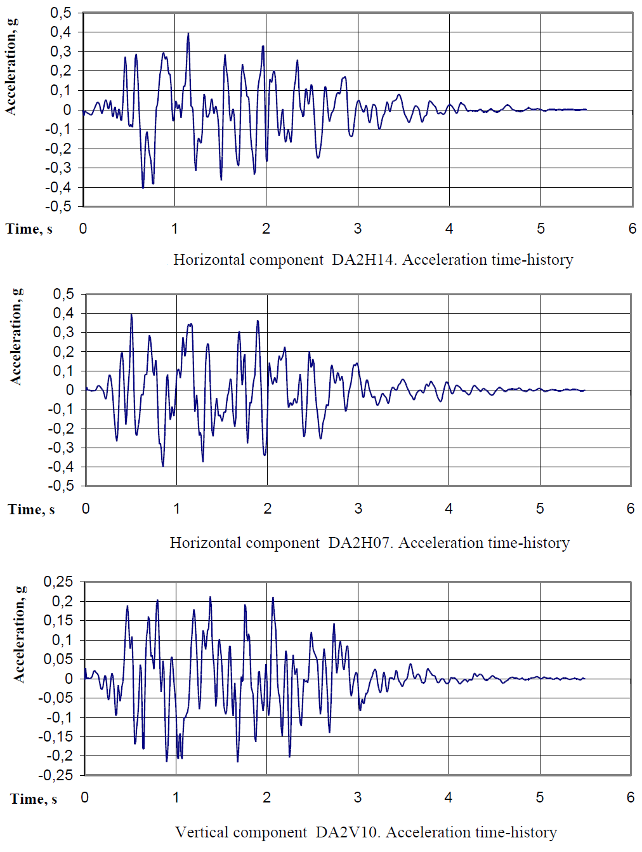: Acceleration time history (horizontal and vertical components.

Local conditions

As required by the IAEA standard NS-R-3 (2016), par. 3.1, local conditions must be considered in seismic hazard analysis. An important parameter is the velocity of shear waves, which must be determined for the foundation medium just below the foundation level of the structure in the natural condition. Based on this parameter, site categorization must be performed for seismic response analysis purposes (See IAEA standard NS-G-3.6 (2004), par. 3.1).

Shear wave velocity values were determined for the sub-surface materials up to a depth of 100 m. The results are shown in Table (See report 49.BU.1 0.0.ОО.FSAR.RDR001 (Chapter 3.7), p. 52).

Table 5: Characteristics of soils of the unit 1 reactor building foundation



Comparing the data in the Table 4 with the limit values according to par. 3.1 of the IAEA standard NS-G-3.6, it is clear that the Bushehr site is type 2, i.e. the shear wave velocity (*VS*) is in the range of 1100-300 m/s.

In this case it is necessary to apply a requirement resulting from the par. 3.7 of the IAEA standard NS-G-3.6, where it is required: “A computation of site response under free field conditions should be carried out for sites other than Type 1 sites”. See Section “Attenuation models”.

Safety margins

The submitted reports do not provide too much information on how the safety margins have been addressed. A passing view of the data and results of seismic hazard analysis shows that a conservative approach has been applied (maybe too much). However, specific information isn’t available. It seems that the margins have been used primarily in estimating Mmax, but it is usual procedure when expert judgement is applied.

However, if we are talking about a safety margin in relation to the DBE value (resp. SL-2), the calculated and adopted values must be differentiated.

In a few countries, the regulatory body requires to calculate the value of SL-2, which corresponds to a level with a probability of being exceeded equal 1 x 10–4 for median value per reactor per year. A lower value cannot be used in the project. The license applicant normally adds a safety margin to this calculated value to reliably secure the safety of the installation. The size of this margin should result from the assessment of SSCs required safety function and their seismic capacity. According to established practice, a value of less than 0.1 g cannot be used in the project (See WENRA document: Guidance on Seismic Events, 10/2015).

It appears that the safety margin was, in the case of Bushehr NPP, solved by using the probability of being exceeded equal 1 x 10–4 for 84th percentile value (or median + σ). This approach has been used in the past; but should be advised to make comparisons with the value of the safety margin that would have been determined using the current approach.

Seismic monitoring

The installation of a seismic monitoring system is recommended by the IAEA standard NS-G-1.6 (2003), Section 7. A minimum amount of seismic instrumentation (See NS-G-1.6, par. 7.4) should be installed at any nuclear power plant site as follows:

* One triaxial strong motion recorder installed to register the free field motion;
* One triaxial strong motion recorder installed to register the motion of the basemat of the reactor building;
* One triaxial strong motion recorder installed on the most representative floor of the reactor building.

If the SL-2 free field acceleration is equal to or greater than 0.25g, the installation of additional seismic instrumentation devices should be considered.

The Bushehr Nuclear Power Plant has an installed seismic monitoring system that meets the requirements of the IAEA standard 50-SG-D15. This system is intended to provide automatic emergency shutdown of the reactor plant at intensity characterized by the maximal horizontal acceleration on a soil free surface of 0.1 g and the maximal vertical acceleration on a soil free surface of 0.05 g. And, of course, registration and logging of the information on seismic impact, too.

Six three-component seismic detectors are in 3 rooms: B0105/1, B0126 and B0105/2 room. Free field signal is registered by the accelerometers of the Iranian seismic station located at the NPP site.

#### Current approaches and requirements

In response to the 2011 Fukushima nuclear accident, risk and safety assessments were carried out on all European NPPs. At the same time, international authorities have made considerable efforts to improve the safety standards and procedures used in external hazard assessments to enhance the safety of nuclear installations. Many of the new approaches to assessing partial issues of seismic hazard analysis have been mentioned in the previous chapter 2.1.1.2. This chapter is devoted to two very important issues, namely:

* screening and assessment of the site-specific natural hazards;
* assessment of the design extension conditions (DEC).

Both issues are discussed in detail in WENRA Guidance Document. Issue T: Natural Hazards. Guidance on Seismic Events. (10/2015).

Screening and assessment of the site-specific natural hazards

If seismo-tectonic hazards are assessed, they must be considered as a minimum:

1. Ground motion hazards and the potential for fault displacement
   1. vibratory ground motion.
   2. near fault effects.
   3. site effects, as variations in the site-specific shear wave velocity, site topography, basin geologic structure.
   4. surface faulting and fault capability.
2. Hazard phenomena triggered by seismo-tectonic events
   1. liquefaction.
   2. settlement induced by seismic shaking.
   3. ground collapse.
   4. earthquake-induced slope instability / underwater landslides.
   5. tsunamis.
   6. failure of dams or other water containment structures due to earthquake.
3. Induced and triggered seismicity caused by human activities as
   1. mining, liquid or gas extraction, hydrofracking.
   2. water pumping.
   3. gas or liquid waste disposal.
   4. build-up of water reservoirs.

It is necessary to develop a methodology for screening and analyzing potential external hazards and conducting the surveys necessary to evaluate threatening natural phenomena. For more detail See Section 3 of the WENRA Guidance Document. Issue T: Natural Hazards. Guidance on Seismic Events. (10/2015). The methodology can be inspired, for example, by the EPRI report “Identification of External Hazards for Analysis in Probabilistic Risk Assessment” (2015).

Assessment of DEC conditions

The concept of the “Design Extension Conditions” is set out in Chapter 2 of the WENRA Guidance Document. Issue F: Design Extension of Existing Reactors. From this chapter follows the basic requirement, which is formulated as follows: “A set of DECs shall be derived and justified”.

The DEC analysis must consider such events, and combinations of events, which cannot be considered with a high degree of confidence to be extremely unlikely to occur and which may lead to severe fuel damage in the core. Such phenomena can be, inter alia, initiated by earthquake, flood or other natural hazards exceeding the design basis events. The effort is to identify and assess a “Beyond design-basis accident”, which is accident sequences that are possible but were not fully considered in the design process because they were judged to be too unlikely.

If the phenomenon relates to an earthquake, it is sought the largest hypothetical earthquake (Maximum Credible Earthquake - MCE). It is an earthquake that may be reasonably expected to occur along a given fault or other seismic source could produce under the current tectonic setting. It is a believable event which can be supported by all known geologic and seismologic data. The definition of MCE is usually based on a combination of deterministic and probabilistic assessments as well as engineering judgement.

More detailed recommendations on how to establish MCE are given in Chapter 6 of WENRA Guidance Document. Issue T: Natural Hazards. Guidance on Seismic Events (2015). Two basic ideas should be observed:

* Demonstrate physical impossibility, if possible.
* Estimate maximum ground shaking or displacement at the site corresponding to the MCE using deterministic methods that are based on the systematic assessment of potentially seismogenic faults in an area extending to a sufficient distance from the site, and of capable faults in an area of not less than 25 km around the site (near regional scale).

A similar approach must be applied to zones of diffused seismicity. MCE estimates can be obtained from the dimension of faults with suitable orientation which may be assumed to move under the current stress conditions.

#### Conclusion on the adequacy of the design basis for the earthquake

In the analysis of seismic hazard presented, it is possible to find an adequate response to all the recommendations and challenges of international practice that were valid at the time the report was written.

A combination of multiple methods (probabilistic, deterministic and macroseismic) and conservatism (perhaps too much) can be considered a strong aspect of analysis. The weakness of the analysis can be seen in the fact that the statements and the results are not clearly supported by the evidence, and it is often difficult to verify them.

A more serious shortcoming is some confusion about the safety margin. It is not clear whether the safety margin is included in the DBE or not. However, the resulting DBE appears to be adequate (on the safety side).

The above text mentions several measures that would help improve seismic hazard analysis. These measures are not only designed to improve the existing analysis but are also directed to meet current requirements using state-of-art approaches. The following measures are very important:

1. better clarify input data (catalogs, break descriptions, models of seismic sources), document them carefully and support them with credible evidence from field surveys;
2. better manage procedures to determine the safety margin and clearly declare its value;
3. add screening and assessment of the site-specific natural hazards;
4. add assessment of the design extension conditions (DEC).

In conclusion, it is necessary to mention the usual practice of periodic verification of NPP safety. Therefore, based on the results of the periodic safety review and this study, it is recommended to elaborate a plan of additional geological and seismological surveys, to implement it and to upgrade analysis of seismic hazard.

## References

IAEA NS-R-3. Site Evaluation for Nuclear Installation, Safety Requirements. Standards Series No. NS-R-3, Rev. 1. IAEA. Vienna 2016.

IAEA NS-G-1.6. Seismic design and qualification for nuclear power plants Safety Guide, Safety Standards Series No. NS-G-1.6. IAEA. Vienna 2003.

IAEA SSG-9. Seismic Hazards in Site Evaluation for Nuclear Installations. Specific Safety Guide, Safety Standards Series No. SSG-9. IAEA. Vienna 2010.

IAEA TECDOC-1767. The Contribution of Palaeoseismology to Seismic Hazard Assessment in Site Evaluation for Nuclear Installations. International Atomic Energy Agency, Vienna 2015.

WENRA (Western European Nuclear Regulators’ Association), 2014. Guidance Document. Issue F: Design Extension of Existing Reactors. Reactor Harmonization Working Group, 29.09.2014.

WENRA (Western European Nuclear Regulators’ Association), 2015. Guidance Document. Issue T: Natural Hazards. Guidance on Seismic Events. (Annex to the Guidance Head Document on Natural Hazards). Reactor Harmonization Working Group, 9.10.2015.

EPRI (Electric Power Research Institute), 2015. Identification of External Hazards for Analysis in Probabilistic Risk Assessment. Update of Report 1022997. Technical Report, 142 pp. October 2015.

Report 18.BU.1 0.0.OO.VAB.PR. NPP “Bushehr”, Unit 1. Probabilistic safety assessment on the project of reconstruction and completion of Unit 1 NPP “Bushehr”. Probabilistic safety assessment for seismic events. Rev. 2. Joint stock company “Atomenergoproekt”, Moscow, 2009.

Report 9S.BU.l 0.0.IZ.PM.PRR04. NPP “Bushehr”, Unit 1. Supplementary Site Investigations for Evaluation of Design Basis Parameters of the Unit. Final Report as per Section No. 1-10 of Attachment Y.A. to Appendix. Volume 2 Regional and Subregional Investigations. Part 2 Seismological Investigations. Appendix. Tehran, 1999.

Report 49.BU.1 0.0.ОО.FSAR.RDR001 (Chapter 2.5). NPP “Bushehr”, Unit 1. Final safety analysis report. Chapter 2 Site characteristic, Book 2, Rev. 2., Atomenergoproekt, Moscow, 2011.

Report 49.BU.1 0.0.ОО.FSAR.RDR001 (Chapter 3.7). NPP “Bushehr”, Unit 1. Final safety analysis report. Chapter 2 Site characteristic, Book 2, Rev. 2., Atomenergoproekt, Moscow, 2011.

Report on safety analyses of Bushehr NPP at extreme external impacts. Atomenergoproekt, Moscow, 2012.