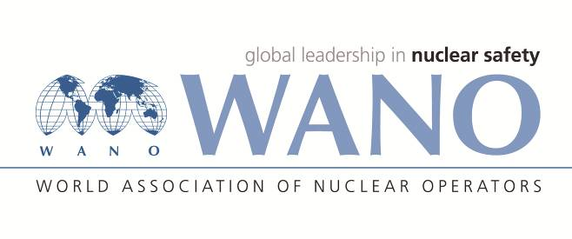 | World Association of Nuclear Operators  Moscow Centre  WANO – MC  25 Ferganskaya st, Moscow, 109507, Russia  Phone. +7 495 376 15 87  Fax: +7 495 376 08 97  info@wanomc.ru

REQUEST
to provide technical and organizational information
via WANO

- NPP/Organization:
Zaporizhzhia NPP, SE “NNEGC “Energoatom”
- Information request topic:
“Techniques and methods of determination of the activity of primary coolant radioactive inert gases for WWER-1000 NPPs (or similar) in the samples under pressure and at atmospheric pressure”
- Information request objective:
Implementation of the best international experience in controlling the activity of radioactive inert gases in primary coolant (measurement of the sample under pressure, measurement of the sample at atmospheric pressure). The use of the obtained results for determination of the type and quantity of fuel element defects, substantiation of the fuel cladding leak detection scope on a shutdown reactor.
- Problem description:
Currently the fuel cladding leak detection on a reactor in operation at Zaporizhzhia NPP is based on the measurement of specific activity of iodine and cesium isotopes. The disadvantage of this method is low efficiency of determination of fuel cladding leak detection in spent fuel assemblies by cesium due to its great amount, and by iodine due to short half-life of isotope. In addition, the isotope of iodine and cesium are chemically active elements trapped by special water treatment facility filters, and they can contact with corrosion sediments on fuel cladding, that reduces efficiency of the fuel cladding leak detection. At the same time, the method of fuel cladding leak detection by activity of chemically radioactive inert gases kr and Xe is used worldwide.
- Specific questions:
It is necessary to provide information on the techniques and methods of determination of the activity of primary coolant radioactive inert gases in the samples under pressure and at atmospheric pressure for WWER-1000 (or similar) reactors, as follows:
1. Description of the techniques of determination of the activity of primary coolant radioactive inert gases in the samples (under pressure and at atmospheric pressure) available at NPPs;
- technique of primary coolant sampling,
- technique of sample storage and transportation,
- technique of sample dilution and preparation for measurement,
- technique of sample measurement,
- technique of results recalculation (as required).
2. Description and characteristics of the instrument channel;
3. metrological certification of the instrument channel.
- Organizations proposed for distribution of this request:
The NPPs operating the WWER reactors, provided that their measurement of radioactive inert gases is conducted in primary coolant under pressure as well as in the sample at atmospheric pressure. The PWR NPPs, provided that their measurement of radioactive inert gases is conducted in primary coolant under pressure as well as in the sample at atmospheric pressure.
- Department – request initiator:
Nuclear Safety Department
- Contact details of the requester:
Name: Mark L. Perepelytsya
Job position: Nuclear Safety Department Deputy Head
Telephone: +3806139-55899
e-mail: oyb39134@mgw.npp.zp.ua
- Request date:
09/01/2019

Deputy Chief Engineer
on Nuclear and Radiation Safety A.I. Ignatchenko

M.L. perepelytsya
55899

