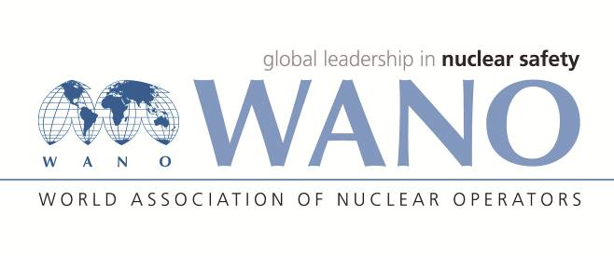 **REGISTRATION FORM**

**RCC working group Meeting**

**Moscow, Russia**

**3-4 December** **2019**

|  |  |
| --- | --- |
| Family name: | EMAMJOMEH |
| First name: | EHSAN |
| Date of birth: | 21/11/1970 |
| Place of birth: | TEHRAN |
| Citizenship: | Iranian |
| Organization: | Nuclear Power Production & Development Co. of Iran |
| Organization address: | No. 8, Tandis St., Africa Ave., Tehran, IRAN |
| Position: | Nuclear Safety Manager |
| Mobile phone: | +98 |
| Phone/Fax: | Phone:(+98) 21-24882869  Fax:(+98) 21-22058895 |
| E-mail: | emamjomeh@nppd.co.ir |
| Passport number: | G9341796 |
| Date of issue: | 23/12/2015 |
| Date of expiry: | 23/12/2020 |

Please specify the title/subject of your presentation and send the electronic versions (Russian and/or English) to the Workshop Coordinators before **November 22, 2019** _________________________________________________________________________________

|  |  |
| --- | --- |
| **Do you need an invitation letter for entry visa (YES/NO):** | No |
| **City were you will apply for Russian visa:** | Tehran |
| **Will you participate in another MC WS (December 5-6, 2019) on experience exchange in reviewing EP&SAM areas during PRs.** | NO |
| **Do you want us to book the hotel for you in Moscow? («MOSUZCENTR» hotel)** | YES |
| Please send a copy of the picture page of your passport (a scanned copy **in JPEG format**) to Workshopcoordinators (please see the contact details below). | |

**Please send the completed form to the Workshop Coordinators before October 15, 2019.**

Date / Flight / Time/Airport of arrival in Moscow : will be announced later   
_________________________________________

Date / Flight / Time/ Airport of departure from Moscow : will be announced later   
_______________________________________________

|  |  |
| --- | --- |
| **WANO-MC Coordinators** | |
| **Andrey LUKYANENKO**  **Tel: + 7 495 221 03 07**  **Fax: + 7 495 376 08 97**  **E-mail:** [**lukianenko@wanomc.ru**](mailto:lukianenko@wanomc.ru) | **Anna TATARINOVA**  **Tel:+7 495 221 02 78**  **Fax:+7 495 376 08 97**  **E-mail:** [**tatarinova@wanomc.ru**](mailto:tatarinova@wanomc.ru) |