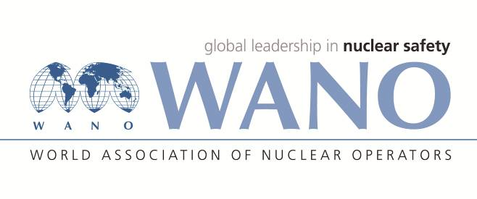 | World Association of Nuclear Operators  Moscow Centre  WANO – MC  25 Ferganskaya, Moscow, 109507, Russia  Phone. +7 495 376 15 87  Fax: +7 495 376 08 97  info@wanomc.ru

REQUEST
to provide technical and organizational information via WANO

- NPP/Organization: Dukovany NPP
- The topic of information request:
Investigating events, root causes and developing corrective actions
- The goal of information request:
Obtain information on event investigations at other NPPs in order to enhance the event investigation process and the development of corrective actions.
- Problem description:
As part of our continuous improvement process, we are looking for ways to improve our internal event investigation process to provide a universal tool for investigating both complex and basic events. We want to gain experience from other NPP operators with their methods and software tools.
If interested, we will be pleased to share the results of our inquiries.
- Specific questions:
- What method does your organization use to investigate events, determine root causes, and develop corrective actions?
- Does your organization use any of the commercially available methods for these activities, including its software support? (TapRooT, Clearinghouse, REASON, PROACT, MORT, …)
- Are you satisfied with this method in the long term, or do you recommend a different approach to event investigation?
- Proposed organizations for sending this request:
All WANO RC
- Department – request initiator:
Performance improvement
- Contact details of the requester:
Position: OE specialist
Name: Jiří Puchnar
Phone: +420 606 806 466
e-mail: jiri.puchnar@cez.cz

- Date of request: 15.02.2022

The request created by:
On-site WANO MC Rep
Mr. Tomáš Kouba
Cell: +420 725 258 854
e-mail: tomas.kouba01@cez.cz

