World Association of Nuclear Operators
Moscow Centre (WANO MC)
25 Ferganskaya, Moscow, 109507, Russia
Phone: +7 495 376 15 87 Fax: +7 495 376 08 97 E-mail: info@wanomc.ru
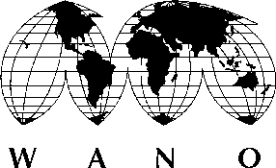
№ МС-14/
28.03.2014
Pages: 1

To: Mr. H. Derakhshandeh, Bushehr NPP Manager and Managing Director
From: Mr. M. Chudakov, Director, WANO Moscow Centre

Sub: Competitive selection for personnel vacancies at WANO-MC

Dear Mr. Derakhshandeh!

Please be advised that your plant employee Mr Hamid Azarbad has successfully completed a WANO-MC competitive selection for a position of the WANO-MC On-site Representative at Bushehr NPP.

The minutes of the WANO-MC Selection Committee meeting that took place in Moscow on 28th of March 2014 will be approved at the 62nd WANO-MC Governing Board Meeting. The copy of the approved minutes will be forwarded to you.

In view of the above, I would ask you to formally assign Mr. Hamid Azarbad as the WANO-MC On-site Representative at Bushehr NPP.

With best regards and hope for future cooperation.

Mikhail Chudakov
WANO-MC Director

