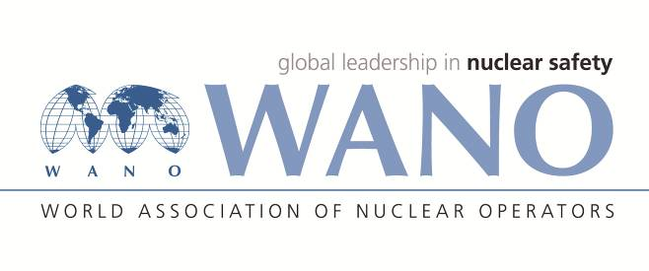 | Московский центр  Всемирная Ассоциация Организаций, эксплуатирующих Атомные Электростанции  ВАО АЭС – МЦ  Россия, 109507, Москва, Ферганская ул., 25  Тел. +7 495 376 15 87  Факс: +7 495 376 08 97  info@wanomc.ru

REQUEST
to provide technical and organizational information via WANO

- NPP/Organization: Rivne NPP / SE "NNEGC "Energoatom"
- The topic of information request:
Ensuring required physical protection level of nuclear facilities and nuclear materials under pandemic conditions.
- The goal of information request:
Sharing experience in the area of physical protection.
- Description of the problem:
Under pandemic conditions NPP operators shall ensure both the nuclear safety and physical protection. In such situation performance of lock-down activities within NPPs ensures decreasing of the main risks, i.e. lack of the personnel important for operation of nuclear facility. Introducing of lock-down envisages revision of several procedures for physical protection of nuclear facilities and nuclear materials.
- Questions:
5.1 Are there any additional limitations regarding access of personnel to the NPP protected area and to the limited access areas within NPP? Are there any changes in the procedure of granting access permissions to NPP?
5.2 How is the needed distance ensured between NPP personnel and security personnel in course of passing the check points during normal working time and during peak hours (checking in/out of shift personnel)?
5.3 How is the contact with potentially "contaminated" surfaces minimized in course of passing the check points during normal working time and during peak hours (checking in/out of shift personnel)? How is identification performed of personnel in course of passing the check points under the lock-down conditions (using PIN-code, biometric identification etc.)?
5.4 How is the access of the main operating personnel organized? Is there any experience of transporting these personnel by buses direct to plant site or arranging permanent stay within NPP?
5.5 Are there any changes in work organization of physical protection personnel and security personnel?
5.6 What are additional limitations with regard to the Physical Protection at NPPs during lock-down?
- Proposed organizations for sending this request:
Nuclear Power Plants
- Department – request initiator:
Department of Physical Protection, Rivne NPP
Contact details of the requester: Ivan Derlyuk, tel: +380 3636 64 2 23,
e-mail: deriy@rnpp.atom.gov.ua
- Date of request: 06.04.2020

