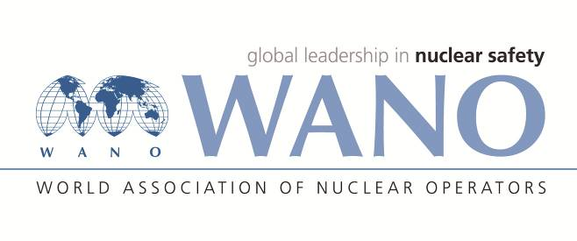 | World Association of Nuclear Operators  Moscow Centre  WANO – MC  25 Ferganskaya, Moscow, 109507, Russia  Phone. +7 495 376 15 87  Fax: +7 495 376 08 97  info@wanomc.ru
REQUEST
to provide technical and organizational information via WANO.
- NPP/Organization: Bushehr NPP Request Number -
- The topic of information request: RECOVERY OF BORIC ACID FROM CONCENTRATED WASTE STREAMS
- The goal of information request: Fabricating and applying of boric acid recovery system
- The describing of problem: Boron-containing anionic species negative affect a process of waste solidification and deteriorate properties of final waste products. Boron separation from concentrated waste streams causes waste minimization and improvement of physical and chemical properties for further waste treatment and conditioning.
- Questions:
1. In your opinion, can we directly use crystallization/pressure filtration process for separating boric acid from radioactive concentrated wastes (from evaporators) and storage-disposal of boric acid crystals as dry solid waste without any pretreatment?
Without knowing the evaporation residue, we cannot tell whether the Paks solution would work in Bushehr. Our recommendation is to test it in laboratory scale.
In MVM Paks Nuclear Power Plant, boric acid separation is preceded by decomplexation (removal of Co-60), ultrafiltration and filtration using Cs-selective ion exchange. The reason for this is that borax, which is produced as a result of this, is releasable and disposable at a hazardous industrial waste disposal site according to Hungarian law.
Boric acid separation from the evaporation residues without removing isotopes is physically possible but entails the following disadvantages:
- The resultant borax remains radioactive and is not allowed to be disposed at the final repository, since it doesn’t meet the acceptance requirements.
- The boric acid separation / crystallization systems become fouled, which makes their handling cumbersome. It has to be considered that the Larox Minimax Pf 4.2. pressure belt filter (currently Outotec oy. Finland) has an open design and was not developed for the use in nuclear industry, so it is not suitable for the filtration and handling of higher activity media.
Since borax is a water soluble material and will contain a part of the evaporation residue’s activity, we don’t consider it suitable for final disposal without additional handling.

2. We would appreciate if you describe the operational process of crystallization?

The steps of crystallization are as follows:
- Placing of about 3.5m³ evaporation residue of pH =12-12.5 with 300-400 g/dm³ total salt content and 200 g/dm³ boric acid content through mechanical prefilters into the 5m³ crystallization container for storage.
- Addition of about 300-400 dm³ HNO₃ with 65% concentration, while constantly stirring and circulating the medium.
- After reaching pH=9.0-9.5, dosing the solution into the pressure filter, while continuing to circulate and stir the medium.
- The pressure filter, in automatic operation, filters the medium, removes the liquid phase, performs washing and drying of the produced borax cake, as well as the discharging of the cake into the sacks mounted under the equipment.

3. We would appreciate if you provide us specifications of additive materials and equipment used in crystallization process?

Prefiltering station

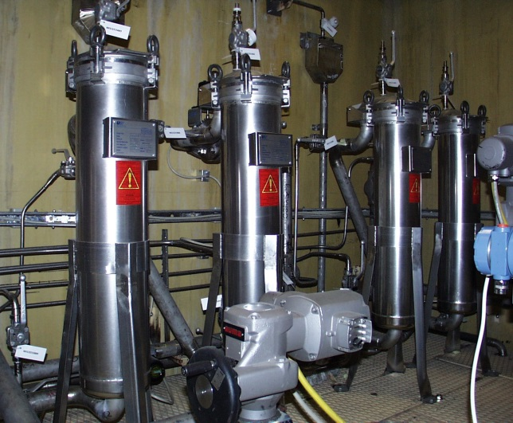

type: COFIPORE C31
manufacturer: USF FILTRATION
maximal volume flowrate: 35 m³/h
nominal volume flowrate: 11 m³/h

Filter bags:
manufacturer: HAYWARD INDUSTRIAL GmbH, GAF Filter Systems
material: polypropylene
size: Ø 180*800 mm
nominal filtration sizes: 1 μm and 10 μm

Crystallization container with stirrer motor

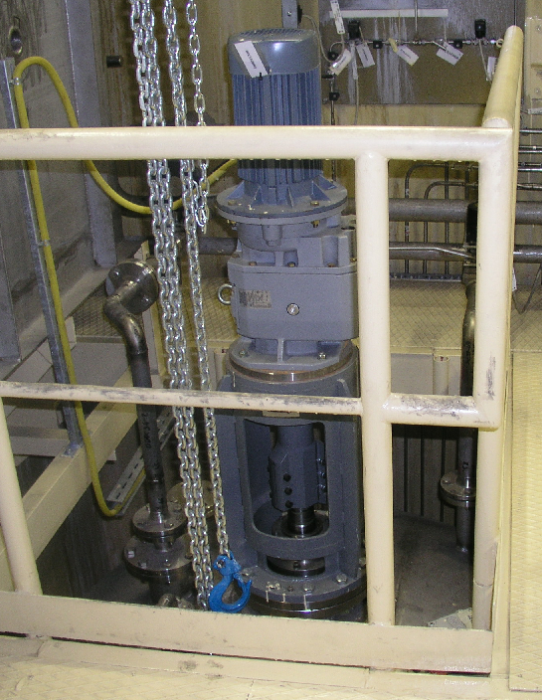
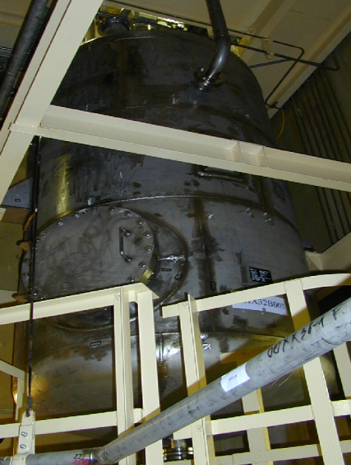
type: custom-manufactured vertical cylinder with flat bottom dome
total volume: 5.77 m³
usable volume: 5.00 m³

Stirrer mechanism data:
function: homogenization of the medium in the crystallization tank
manufacturer: Agisys
design: custom designed stirrer with one axial blade
speed: 112 1/min
Motor:
voltage: 380 V, 50 Hz
rated power: 5.5 kW

Circulation pumps

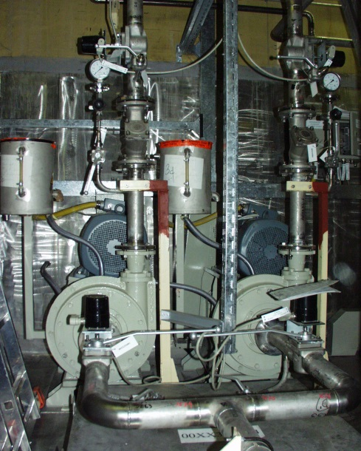

function: continuous stirring of the medium in the crystallization tank and transfer of the medium to the LAROX
manufacturer: Habermann GmbH
type: HPK 40-300
operating temperature: 10-40 °C
rated pressure: 6 bar
maximal pressure: 10 bar
rated capacity: 20 m³/h
grain size in the medium: 15-250 μm
speed: 810-2140 1/min (regulated by frequency converter)
Motor:
voltage: 380 V, 50 Hz
rated power: 30 kW

Larox pressure filter
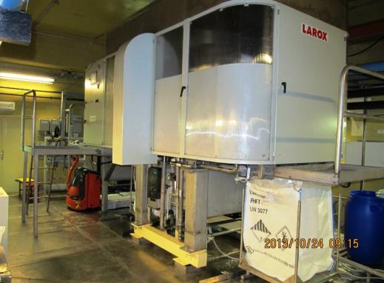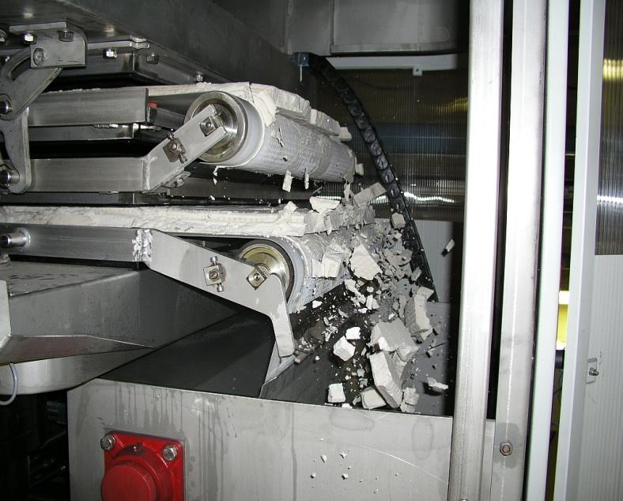
manufacturer: LAROX
type: Minimax PF 4.7
filter capacity: 1 m³/h
filter surface: 4.7 m²
filtration size: 15 μm

4. We would appreciate if you describe the operational process of pressure filtration and provide us technical specifications of filter?

Step 01: Pressure release:
Opening of the valves on the upstream and downstream collectors to allow potential pressure release.

Step 02: Plate pack opening:
Opening of the filter plates until reaching the end position of the hydraulic system.

Step 03: Cake discharge:
Discharging of the borax cake on the filter cloth into the big-bag sacks.

Step 05: Plate pack closing:
Closing of the plates, followed by their sealing by the hydraulic system at 240 bar pressure.

Step 07: Filtration:
The Larox press moves the circulated crystalline medium toward the closed filter plates. Filtration time may be adjusted depending on the quantity of borax accumulating on the filter plates.

Step 08: Pipe washing:
Condensate backwashing of the equipment distribution pipe leading to the plates.

Step 09: Hose washing:
Washing of the hoses leading to and from the filter plates.

Step 12: Pressing 2:
In order to reduce the moisture content of the borax accumulated on the filter plate, a rubber diaphragm is pressed against the cake to remove more liquid from it.

Step 13: Pipe drain:
Depressurization and draining of the distribution pipe after pressing.

Step 14: Air drying:
Drying of the borax cake.
After that, the system jumps to step 01 and restarts the program from the beginning.

Step 04: Restart operations:
If the filter cloth reaches the lower end position, it is automatically rolled back the equipment, while being washed on both sides with condensate.

- Proposed organizations for sending this request: Paks NPP
- Department – request initiator: Safety development & improvement Group of the Bushehr NPP
- Contact details of the requester: Abolfazl Maftoon, Group: Waste Management, Mang. Deputy: Technical Support Organization
- Date of request: 18.12.2018

Hamid Azarbad
Х. Азарбад
Представитель ВАО АЭС-МЦ на АЭС Бушер
WANO-MC OSR at BUSHEHR NPP
Phone: +98 773 111 2156
Fax: +98 773 111 2157
Сell: +98 917 351 6368
E-mail: azarbad@wanomc.ru

